Critical Thinking Group 4 : DATA621 Homework 1

Table of Contents

TEAM Members: 2

**1 Overview** 2

**2 Deliverables** 3

**3 DATA EXPLORATION** 3

**3.1 View rows and columns, variable types** 4

**3.2 Structure of data** 5

**3.3 Mean and Median of the data** 10

**3.4 Rename Columns** 10

**3.5 Visualize the data** 11

**3.6 Multivariate Plot** 12

**3.7 Missing or NA Values** 19

**3.8 Zero Values** 19

**3.9 Checking for outliers** 20

**3.10 Checking for skewness in the data** 21

**3.11 Finding correlations** 21

**3.12 Missing value by Graph** 26

**3.13 Initial Observations** 27

**4 DATA PREPARATION** 27

**4.1 Fixing Missing/Zero Values** 27

**4.2 Imputing the values using KNN** 27

**5 BUILD MODELS** 28

**5.1 Model 1 (Kitchen Sink Model/Backward Elimination)** 28

**5.1.1 Plot Model1** 29

**5.2 Model 2 : Simple Model** 30

**5.2.1 Plot Model 2** 31

**5.3 Model 3 : Higher Order Stepwise Regression** 32

**5.4 StepBack Model** 36

**5.4.1 Plot Model3, Model3a, Model3b** 37

**6 SELECT MODELS** 40

**6.0.1 Multicollinearity** 41

**6.0.2 Model 2** 43

**6.1 Predict of Eval data** 48

**7 CONCLUSION** 48

Appendix: 49

Thank you 49

## TEAM Members:

Rajwant Mishra  
Priya Shaji  
Debabrata Kabiraj  
Isabel Ramesar  
Sin Ying Wong  
Fan Xu

-------------------------------------------------

**1 Overview**

In this homework assignment, you will explore, analyze and model a data set containing approximately 2200 records. Each record represents a professional baseball team from the years 1871 to 2006 inclusive. Each record has the performance of the team for the given year, with all of the statistics adjusted to match the performance of a 162 game season.

We have been given a dataset with 2276 records summarizing a major league baseball team’s season. The records span 1871 to 2006 inclusive. All statistics have been adjusted to match the performance of a 162 game season.

Your objective is to build a multiple linear regression model on the training data to predict the number of wins for the team. You can only use the variables given to you (or variables that you derive from the variables provided).

**Glossary of data**

Code

Below is a short description of the variables of interest in the data set:  
 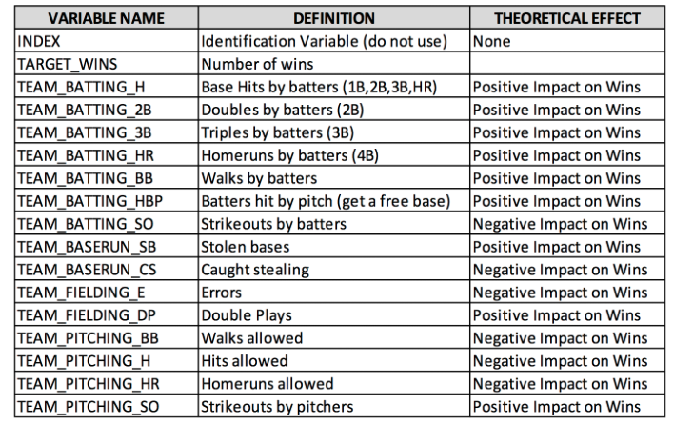

**2 Deliverables**

* A write-up submitted in PDF format. Your write-up should have four sections. Each one is described below. You may assume you are addressing me as a fellow data scientist, so do not need to shy away from technical details.
* Assigned predictions (the number of wins for the team) for the evaluation data set.
* Include your R statistical programming code in an Appendix.

**3 DATA EXPLORATION**

The data set describes baseball team statistics for the years 1871 to 2006 inclusive. Each record in the data set represents the performance of the team for the given year adjusted to the current length of the season - 162 games. The data set includes 16 variables and the training set includes 2,276 records.

Load the data and understand the data by using some stats and plot

Code

**3.1 View rows and columns, variable types**

Glimpse of the data shows that all variables are numeric, no categorical variable is present here. We do lots of NA for few predictors in the data set. In our further analysis we will try to identify:

* Structure of the each predictors
* How Many NA and Zero , is it significant to remove them or replace them with some predicted value.
* Statistical summary of the data

Code

## Observations: 2,276

## Variables: 17

## $ INDEX <int> 1, 2, 3, 4, 5, 6, 7, 8, 11, 12, 13, 15, 16, 17, 18...

## $ TARGET_WINS <int> 39, 70, 86, 70, 82, 75, 80, 85, 86, 76, 78, 68, 72...

## $ TEAM_BATTING_H <int> 1445, 1339, 1377, 1387, 1297, 1279, 1244, 1273, 13...

## $ TEAM_BATTING_2B <int> 194, 219, 232, 209, 186, 200, 179, 171, 197, 213, ...

## $ TEAM_BATTING_3B <int> 39, 22, 35, 38, 27, 36, 54, 37, 40, 18, 27, 31, 41...

## $ TEAM_BATTING_HR <int> 13, 190, 137, 96, 102, 92, 122, 115, 114, 96, 82, ...

## $ TEAM_BATTING_BB <int> 143, 685, 602, 451, 472, 443, 525, 456, 447, 441, ...

## $ TEAM_BATTING_SO <int> 842, 1075, 917, 922, 920, 973, 1062, 1027, 922, 82...

## $ TEAM_BASERUN_SB <int> NA, 37, 46, 43, 49, 107, 80, 40, 69, 72, 60, 119, ...

## $ TEAM_BASERUN_CS <int> NA, 28, 27, 30, 39, 59, 54, 36, 27, 34, 39, 79, 10...

## $ TEAM_BATTING_HBP <int> NA, NA, NA, NA, NA, NA, NA, NA, NA, NA, NA, NA, NA...

## $ TEAM_PITCHING_H <int> 9364, 1347, 1377, 1396, 1297, 1279, 1244, 1281, 13...

## $ TEAM_PITCHING_HR <int> 84, 191, 137, 97, 102, 92, 122, 116, 114, 96, 86, ...

## $ TEAM_PITCHING_BB <int> 927, 689, 602, 454, 472, 443, 525, 459, 447, 441, ...

## $ TEAM_PITCHING_SO <int> 5456, 1082, 917, 928, 920, 973, 1062, 1033, 922, 8...

## $ TEAM_FIELDING_E <int> 1011, 193, 175, 164, 138, 123, 136, 112, 127, 131,...

## $ TEAM_FIELDING_DP <int> NA, 155, 153, 156, 168, 149, 186, 136, 169, 159, 1...

Sample 6 rows with sample 7 columns

Code

|  |
| --- |
|  |

|  | **INDEX**  <int> | **TARGET_WINS**  <int> | **TEAM_BATTING_H**  <int> | **TEAM_BATTING_2B**  <int> | **TEAM_BATTING_3B**  <int> | **TEAM_BATTING_HR**  <int> |  |
| --- | --- | --- | --- | --- | --- | --- | --- |
| 1 | 1 | 39 | 1445 | 194 | 39 | 13 |  |
| 2 | 2 | 70 | 1339 | 219 | 22 | 190 |  |
| 3 | 3 | 86 | 1377 | 232 | 35 | 137 |  |
| 4 | 4 | 70 | 1387 | 209 | 38 | 96 |  |
| 5 | 5 | 82 | 1297 | 186 | 27 | 102 |  |
| 6 | 6 | 75 | 1279 | 200 | 36 | 92 |  |

6 rows | 1-7 of 18 columns

Show entire dataset of training data:

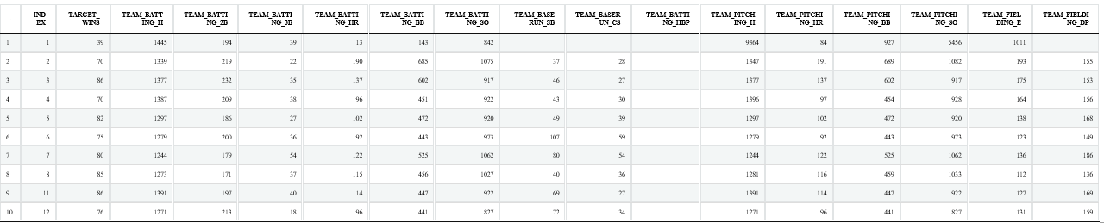

Showing 1 to 10 of 2,276 entries

Previous12345…228Next

Show entire dataset of evaluation data

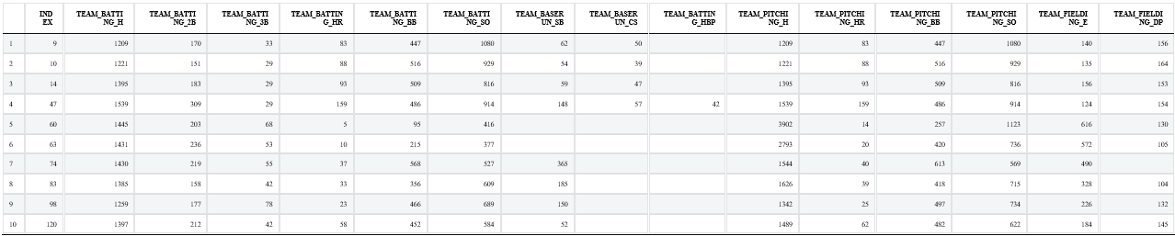

Showing 1 to 10 of 259 entries

Previous12345…26Next

**3.2 Structure of data**

Dimension of Test dataset is, 2276 X 17 with 2276 number of observation in test data.

Summary of the test data shows very clearly that we have six predictors which has NA and BATTING_HBP and BASERUN_CS have the max number of NAs in the data set.

## INDEX TARGET_WINS TEAM_BATTING_H TEAM_BATTING_2B

## Min. : 1.0 Min. : 0.00 Min. : 891 Min. : 69.0

## 1st Qu.: 630.8 1st Qu.: 71.00 1st Qu.:1383 1st Qu.:208.0

## Median :1270.5 Median : 82.00 Median :1454 Median :238.0

## Mean :1268.5 Mean : 80.79 Mean :1469 Mean :241.2

## 3rd Qu.:1915.5 3rd Qu.: 92.00 3rd Qu.:1537 3rd Qu.:273.0

## Max. :2535.0 Max. :146.00 Max. :2554 Max. :458.0

##

## TEAM_BATTING_3B TEAM_BATTING_HR TEAM_BATTING_BB TEAM_BATTING_SO

## Min. : 0.00 Min. : 0.00 Min. : 0.0 Min. : 0.0

## 1st Qu.: 34.00 1st Qu.: 42.00 1st Qu.:451.0 1st Qu.: 548.0

## Median : 47.00 Median :102.00 Median :512.0 Median : 750.0

## Mean : 55.25 Mean : 99.61 Mean :501.6 Mean : 735.6

## 3rd Qu.: 72.00 3rd Qu.:147.00 3rd Qu.:580.0 3rd Qu.: 930.0

## Max. :223.00 Max. :264.00 Max. :878.0 Max. :1399.0

## NA's :102

## TEAM_BASERUN_SB TEAM_BASERUN_CS TEAM_BATTING_HBP TEAM_PITCHING_H

## Min. : 0.0 Min. : 0.0 Min. :29.00 Min. : 1137

## 1st Qu.: 66.0 1st Qu.: 38.0 1st Qu.:50.50 1st Qu.: 1419

## Median :101.0 Median : 49.0 Median :58.00 Median : 1518

## Mean :124.8 Mean : 52.8 Mean :59.36 Mean : 1779

## 3rd Qu.:156.0 3rd Qu.: 62.0 3rd Qu.:67.00 3rd Qu.: 1682

## Max. :697.0 Max. :201.0 Max. :95.00 Max. :30132

## NA's :131 NA's :772 NA's :2085

## TEAM_PITCHING_HR TEAM_PITCHING_BB TEAM_PITCHING_SO TEAM_FIELDING_E

## Min. : 0.0 Min. : 0.0 Min. : 0.0 Min. : 65.0

## 1st Qu.: 50.0 1st Qu.: 476.0 1st Qu.: 615.0 1st Qu.: 127.0

## Median :107.0 Median : 536.5 Median : 813.5 Median : 159.0

## Mean :105.7 Mean : 553.0 Mean : 817.7 Mean : 246.5

## 3rd Qu.:150.0 3rd Qu.: 611.0 3rd Qu.: 968.0 3rd Qu.: 249.2

## Max. :343.0 Max. :3645.0 Max. :19278.0 Max. :1898.0

## NA's :102

## TEAM_FIELDING_DP

## Min. : 52.0

## 1st Qu.:131.0

## Median :149.0

## Mean :146.4

## 3rd Qu.:164.0

## Max. :228.0

## NA's :286

Code

## mtd

##

## 17 Variables 2276 Observations

## --------------------------------------------------------------------------------

## INDEX

## n missing distinct Info Mean Gmd .05 .10

## 2276 0 2276 1 1268 850.4 125.8 252.5

## .25 .50 .75 .90 .95

## 630.8 1270.5 1915.5 2287.5 2407.2

##

## lowest : 1 2 3 4 5, highest: 2531 2532 2533 2534 2535

## --------------------------------------------------------------------------------

## TARGET_WINS

## n missing distinct Info Mean Gmd .05 .10

## 2276 0 108 1 80.79 17.47 54.0 61.0

## .25 .50 .75 .90 .95

## 71.0 82.0 92.0 99.5 104.0

##

## lowest : 0 12 14 17 21, highest: 128 129 134 135 146

## --------------------------------------------------------------------------------

## TEAM_BATTING_H

## n missing distinct Info Mean Gmd .05 .10

## 2276 0 569 1 1469 149.8 1282 1315

## .25 .50 .75 .90 .95

## 1383 1454 1537 1636 1695

##

## lowest : 891 992 1009 1116 1122, highest: 2333 2343 2372 2496 2554

## --------------------------------------------------------------------------------

## TEAM_BATTING_2B

## n missing distinct Info Mean Gmd .05 .10

## 2276 0 240 1 241.2 52.89 167 182

## .25 .50 .75 .90 .95

## 208 238 273 303 320

##

## lowest : 69 112 113 118 123, highest: 382 392 393 403 458

## --------------------------------------------------------------------------------

## TEAM_BATTING_3B

## n missing distinct Info Mean Gmd .05 .10

## 2276 0 144 1 55.25 30.34 23 27

## .25 .50 .75 .90 .95

## 34 47 72 96 108

##

## lowest : 0 8 9 11 12, highest: 166 190 197 200 223

## --------------------------------------------------------------------------------

## TEAM_BATTING_HR

## n missing distinct Info Mean Gmd .05 .10

## 2276 0 243 1 99.61 69.49 14.0 20.0

## .25 .50 .75 .90 .95

## 42.0 102.0 147.0 179.5 199.0

##

## lowest : 0 3 4 5 6, highest: 247 249 257 260 264

## --------------------------------------------------------------------------------

## TEAM_BATTING_BB

## n missing distinct Info Mean Gmd .05 .10

## 2276 0 533 1 501.6 130.1 248.2 363.5

## .25 .50 .75 .90 .95

## 451.0 512.0 580.0 635.0 670.2

##

## lowest : 0 12 29 34 45, highest: 815 819 824 860 878

## --------------------------------------------------------------------------------

## TEAM_BATTING_SO

## n missing distinct Info Mean Gmd .05 .10

## 2174 102 822 1 735.6 282.2 359 421

## .25 .50 .75 .90 .95

## 548 750 930 1049 1103

##

## lowest : 0 66 67 72 74, highest: 1303 1320 1326 1335 1399

## --------------------------------------------------------------------------------

## TEAM_BASERUN_SB

## n missing distinct Info Mean Gmd .05 .10

## 2145 131 348 1 124.8 87.96 35.0 44.0

## .25 .50 .75 .90 .95

## 66.0 101.0 156.0 231.0 301.8

##

## lowest : 0 14 18 19 20, highest: 562 567 632 654 697

## --------------------------------------------------------------------------------

## TEAM_BASERUN_CS

## n missing distinct Info Mean Gmd .05 .10

## 1504 772 128 1 52.8 23.24 24 30

## .25 .50 .75 .90 .95

## 38 49 62 77 91

##

## lowest : 0 7 11 12 14, highest: 171 186 193 200 201

## --------------------------------------------------------------------------------

## TEAM_BATTING_HBP

## n missing distinct Info Mean Gmd .05 .10

## 191 2085 55 0.999 59.36 14.61 40.0 44.0

## .25 .50 .75 .90 .95

## 50.5 58.0 67.0 76.0 82.5

##

## lowest : 29 30 35 38 39, highest: 87 88 89 90 95

## --------------------------------------------------------------------------------

## TEAM_PITCHING_H

## n missing distinct Info Mean Gmd .05 .10

## 2276 0 843 1 1779 628.1 1316 1356

## .25 .50 .75 .90 .95

## 1419 1518 1682 2058 2563

##

## lowest : 1137 1168 1184 1187 1202, highest: 16038 16871 20088 24057 30132

## --------------------------------------------------------------------------------

## TEAM_PITCHING_HR

## n missing distinct Info Mean Gmd .05 .10

## 2276 0 256 1 105.7 70.02 18.0 25.0

## .25 .50 .75 .90 .95

## 50.0 107.0 150.0 187.0 209.2

##

## lowest : 0 3 4 5 6, highest: 291 297 301 320 343

## --------------------------------------------------------------------------------

## TEAM_PITCHING_BB

## n missing distinct Info Mean Gmd .05 .10

## 2276 0 535 1 553 140.7 377.0 417.5

## .25 .50 .75 .90 .95

## 476.0 536.5 611.0 693.5 757.0

##

## lowest : 0 119 124 131 140, highest: 2169 2396 2840 2876 3645

## --------------------------------------------------------------------------------

## TEAM_PITCHING_SO

## n missing distinct Info Mean Gmd .05 .10

## 2174 102 823 1 817.7 316.9 421.3 490.0

## .25 .50 .75 .90 .95

## 615.0 813.5 968.0 1095.0 1173.0

##

## lowest : 0 181 205 208 252, highest: 3450 4224 5456 12758 19278

##

## Value 0 200 400 600 800 1000 1200 1400 1600 1800 2200

## Frequency 20 7 211 554 593 580 156 35 7 2 1

## Proportion 0.009 0.003 0.097 0.255 0.273 0.267 0.072 0.016 0.003 0.001 0.000

##

## Value 2400 3400 4200 5400 12800 19200

## Frequency 3 1 1 1 1 1

## Proportion 0.001 0.000 0.000 0.000 0.000 0.000

##

## For the frequency table, variable is rounded to the nearest 200

## --------------------------------------------------------------------------------

## TEAM_FIELDING_E

## n missing distinct Info Mean Gmd .05 .10

## 2276 0 549 1 246.5 190.4 100.0 109.0

## .25 .50 .75 .90 .95

## 127.0 159.0 249.2 542.0 716.0

##

## lowest : 65 66 68 72 74, highest: 1567 1728 1740 1890 1898

## --------------------------------------------------------------------------------

## TEAM_FIELDING_DP

## n missing distinct Info Mean Gmd .05 .10

## 1990 286 144 1 146.4 29.29 98 109

## .25 .50 .75 .90 .95

## 131 149 164 178 186

##

## lowest : 52 64 68 71 72, highest: 215 218 219 225 228

## --------------------------------------------------------------------------------

Code

## [1] "INDEX" "TARGET_WINS" "TEAM_BATTING_H" "TEAM_BATTING_2B"

## [5] "TEAM_BATTING_3B" "TEAM_BATTING_HR" "TEAM_BATTING_BB" "TEAM_BATTING_SO"

## [9] "TEAM_BASERUN_SB" "TEAM_BASERUN_CS" "TEAM_BATTING_HBP" "TEAM_PITCHING_H"

## [13] "TEAM_PITCHING_HR" "TEAM_PITCHING_BB" "TEAM_PITCHING_SO" "TEAM_FIELDING_E"

## [17] "TEAM_FIELDING_DP"

Code

## 'data.frame': 2276 obs. of 17 variables:

## $ INDEX : int 1 2 3 4 5 6 7 8 11 12 ...

## $ TARGET_WINS : int 39 70 86 70 82 75 80 85 86 76 ...

## $ TEAM_BATTING_H : int 1445 1339 1377 1387 1297 1279 1244 1273 1391 1271 ...

## $ TEAM_BATTING_2B : int 194 219 232 209 186 200 179 171 197 213 ...

## $ TEAM_BATTING_3B : int 39 22 35 38 27 36 54 37 40 18 ...

## $ TEAM_BATTING_HR : int 13 190 137 96 102 92 122 115 114 96 ...

## $ TEAM_BATTING_BB : int 143 685 602 451 472 443 525 456 447 441 ...

## $ TEAM_BATTING_SO : int 842 1075 917 922 920 973 1062 1027 922 827 ...

## $ TEAM_BASERUN_SB : int NA 37 46 43 49 107 80 40 69 72 ...

## $ TEAM_BASERUN_CS : int NA 28 27 30 39 59 54 36 27 34 ...

## $ TEAM_BATTING_HBP: int NA NA NA NA NA NA NA NA NA NA ...

## $ TEAM_PITCHING_H : int 9364 1347 1377 1396 1297 1279 1244 1281 1391 1271 ...

## $ TEAM_PITCHING_HR: int 84 191 137 97 102 92 122 116 114 96 ...

## $ TEAM_PITCHING_BB: int 927 689 602 454 472 443 525 459 447 441 ...

## $ TEAM_PITCHING_SO: int 5456 1082 917 928 920 973 1062 1033 922 827 ...

## $ TEAM_FIELDING_E : int 1011 193 175 164 138 123 136 112 127 131 ...

## $ TEAM_FIELDING_DP: int NA 155 153 156 168 149 186 136 169 159 ...

**3.3 Mean and Median of the data**

Code

|  | **INDEX** | **TARGET_WINS** | **TEAM_BATTING_H** | **TEAM_BATTING_2B** | **TEAM_BATTING_3B** | **TEAM_BATTING_HR** | **TEAM_BATTING_BB** | **TEAM_BATTING_SO** | **TEAM_BASERUN_SB** | **TEAM_BASERUN_CS** | **TEAM_BATTING_HBP** | **TEAM_PITCHING_H** | **TEAM_PITCHING_HR** | **TEAM_PITCHING_BB** | **TEAM_PITCHING_SO** | **TEAM_FIELDING_E** | **TEAM_FIELDING_DP** |
| --- | --- | --- | --- | --- | --- | --- | --- | --- | --- | --- | --- | --- | --- | --- | --- | --- | --- |
|  | Min. : 1.0 | Min. : 0.00 | Min. : 891 | Min. : 69.0 | Min. : 0.00 | Min. : 0.00 | Min. : 0.0 | Min. : 0.0 | Min. : 0.0 | Min. : 0.0 | Min. :29.00 | Min. : 1137 | Min. : 0.0 | Min. : 0.0 | Min. : 0.0 | Min. : 65.0 | Min. : 52.0 |
|  | 1st Qu.: 630.8 | 1st Qu.: 71.00 | 1st Qu.:1383 | 1st Qu.:208.0 | 1st Qu.: 34.00 | 1st Qu.: 42.00 | 1st Qu.:451.0 | 1st Qu.: 548.0 | 1st Qu.: 66.0 | 1st Qu.: 38.0 | 1st Qu.:50.50 | 1st Qu.: 1419 | 1st Qu.: 50.0 | 1st Qu.: 476.0 | 1st Qu.: 615.0 | 1st Qu.: 127.0 | 1st Qu.:131.0 |
|  | Median :1270.5 | Median : 82.00 | Median :1454 | Median :238.0 | Median : 47.00 | Median :102.00 | Median :512.0 | Median : 750.0 | Median :101.0 | Median : 49.0 | Median :58.00 | Median : 1518 | Median :107.0 | Median : 536.5 | Median : 813.5 | Median : 159.0 | Median :149.0 |
|  | Mean :1268.5 | Mean : 80.79 | Mean :1469 | Mean :241.2 | Mean : 55.25 | Mean : 99.61 | Mean :501.6 | Mean : 735.6 | Mean :124.8 | Mean : 52.8 | Mean :59.36 | Mean : 1779 | Mean :105.7 | Mean : 553.0 | Mean : 817.7 | Mean : 246.5 | Mean :146.4 |
|  | 3rd Qu.:1915.5 | 3rd Qu.: 92.00 | 3rd Qu.:1537 | 3rd Qu.:273.0 | 3rd Qu.: 72.00 | 3rd Qu.:147.00 | 3rd Qu.:580.0 | 3rd Qu.: 930.0 | 3rd Qu.:156.0 | 3rd Qu.: 62.0 | 3rd Qu.:67.00 | 3rd Qu.: 1682 | 3rd Qu.:150.0 | 3rd Qu.: 611.0 | 3rd Qu.: 968.0 | 3rd Qu.: 249.2 | 3rd Qu.:164.0 |
|  | Max. :2535.0 | Max. :146.00 | Max. :2554 | Max. :458.0 | Max. :223.00 | Max. :264.00 | Max. :878.0 | Max. :1399.0 | Max. :697.0 | Max. :201.0 | Max. :95.00 | Max. :30132 | Max. :343.0 | Max. :3645.0 | Max. :19278.0 | Max. :1898.0 | Max. :228.0 |
|  | NA | NA | NA | NA | NA | NA | NA | NA’s :102 | NA’s :131 | NA’s :772 | NA’s :2085 | NA | NA | NA | NA’s :102 | NA | NA’s :286 |

BATTING_HBP is showing very close mean and median value, and we suspect its due less number of datapoints. Remember we noted highest number of NA in this predictor. Apart from FIELDING_E we don’t see any big difference in the mean and median of the data.

**3.4 Rename Columns**

Here we removing the TEAM_ from the column name so that we can display it in the plots, and make it easy to read.

Names Before: INDEX, TARGET_WINS, TEAM_BATTING_H, TEAM_BATTING_2B, TEAM_BATTING_3B, TEAM_BATTING_HR, TEAM_BATTING_BB, TEAM_BATTING_SO, TEAM_BASERUN_SB, TEAM_BASERUN_CS, TEAM_BATTING_HBP, TEAM_PITCHING_H, TEAM_PITCHING_HR, TEAM_PITCHING_BB, TEAM_PITCHING_SO, TEAM_FIELDING_E, TEAM_FIELDING_DP

Code

Names After : TARGET_WINS, BATTING_H, BATTING_2B, BATTING_3B, BATTING_HR, BATTING_BB, BATTING_SO, BASERUN_SB, BASERUN_CS, BATTING_HBP, PITCHING_H, PITCHING_HR, PITCHING_BB, PITCHING_SO, FIELDING_E, FIELDING_DP

**3.5 Visualize the data**

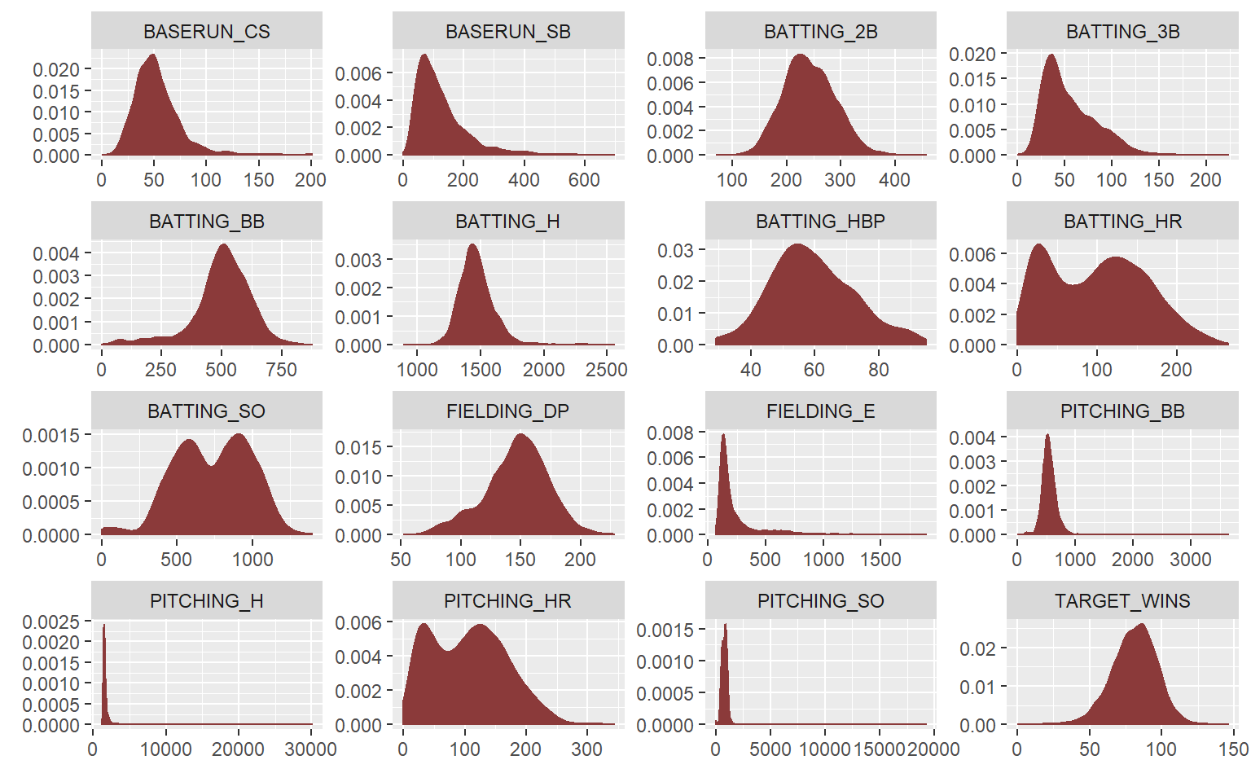

In the histogram plot above, we see that the batting, pitching home-run and batting strike-out variables are bi modal. TARGET_WINS and TEAM_BATTING_2B has most the normal distribution. PITCHING_H and PITCHING_SO have the most skewed data distribution. The skewed graphs are all rght-skewed except BATTING_BB.

Code

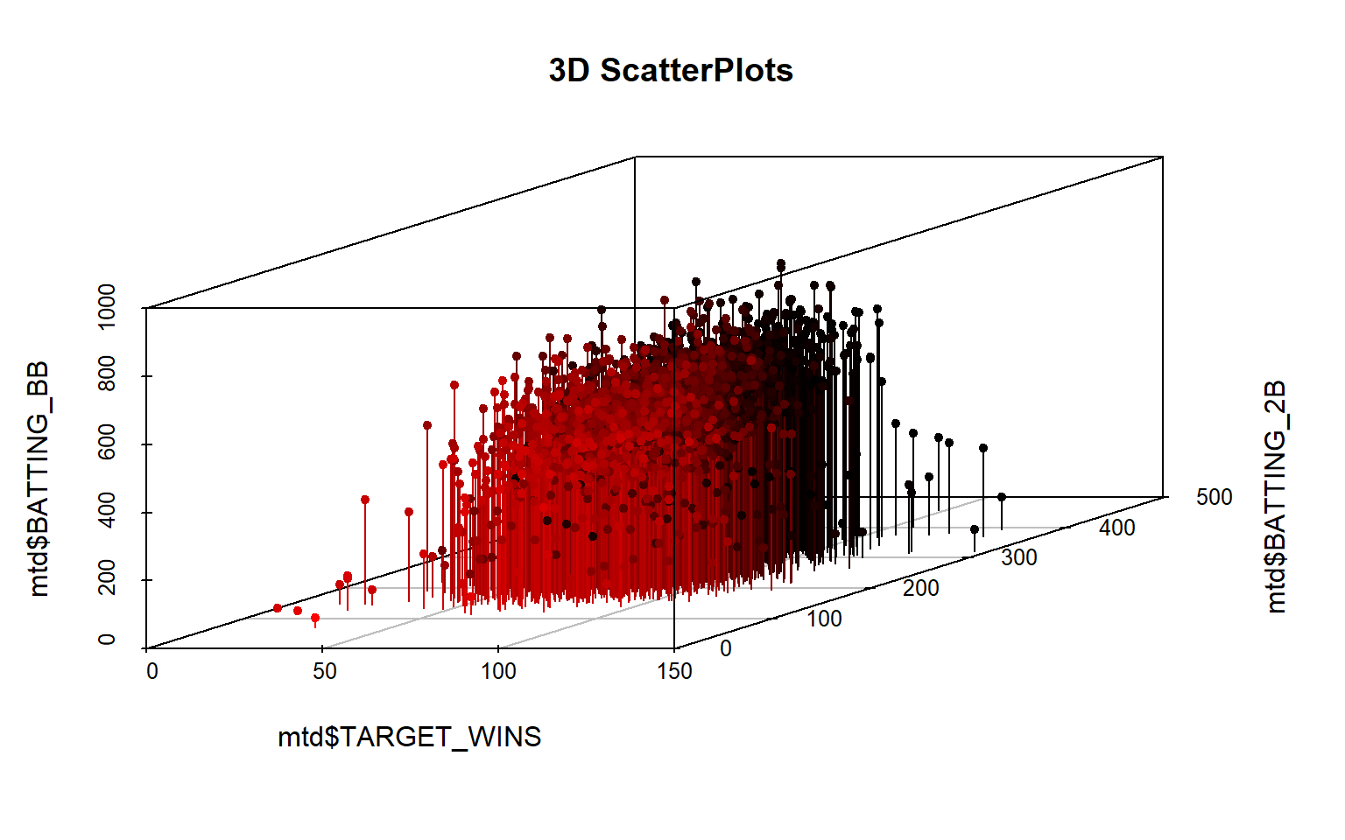

The above 3-D scatter plot, shows the data variance between the TARGET_WINS, TEAM_BATTING_2B and TEAM_BATTING_BB to provide a comparative 3D view.

**3.6 Multivariate Plot**

We will evalaute Frequency (Histogram of Variables) and Regression fit of each predictor with TARGET_WIN.

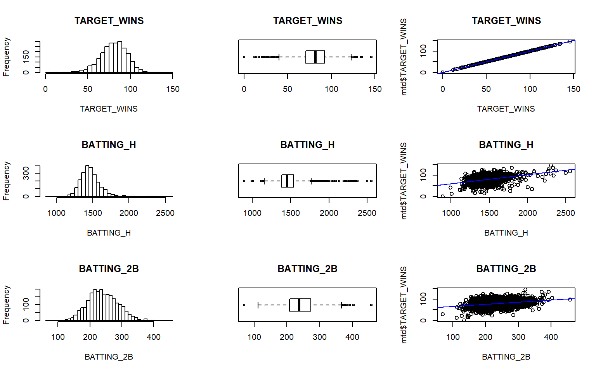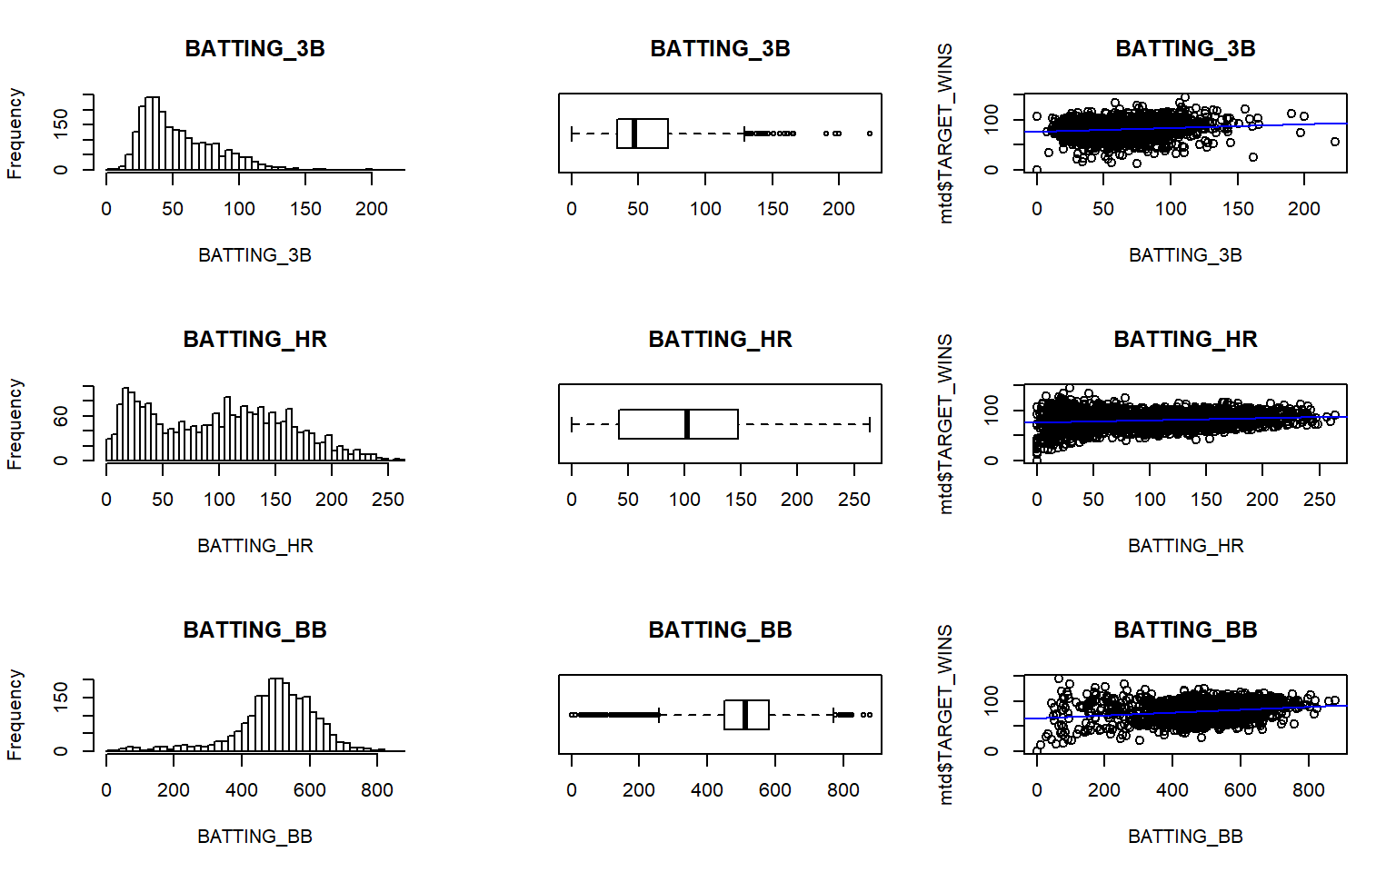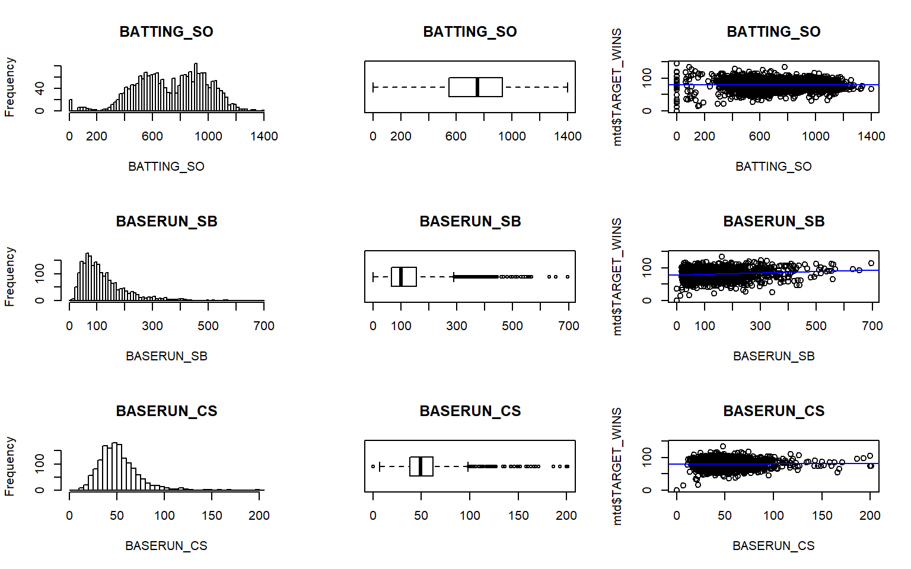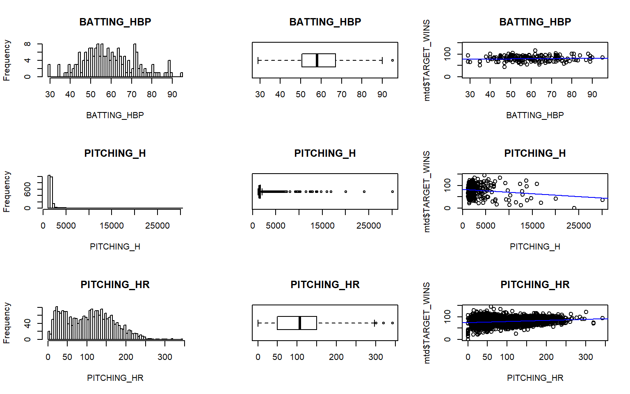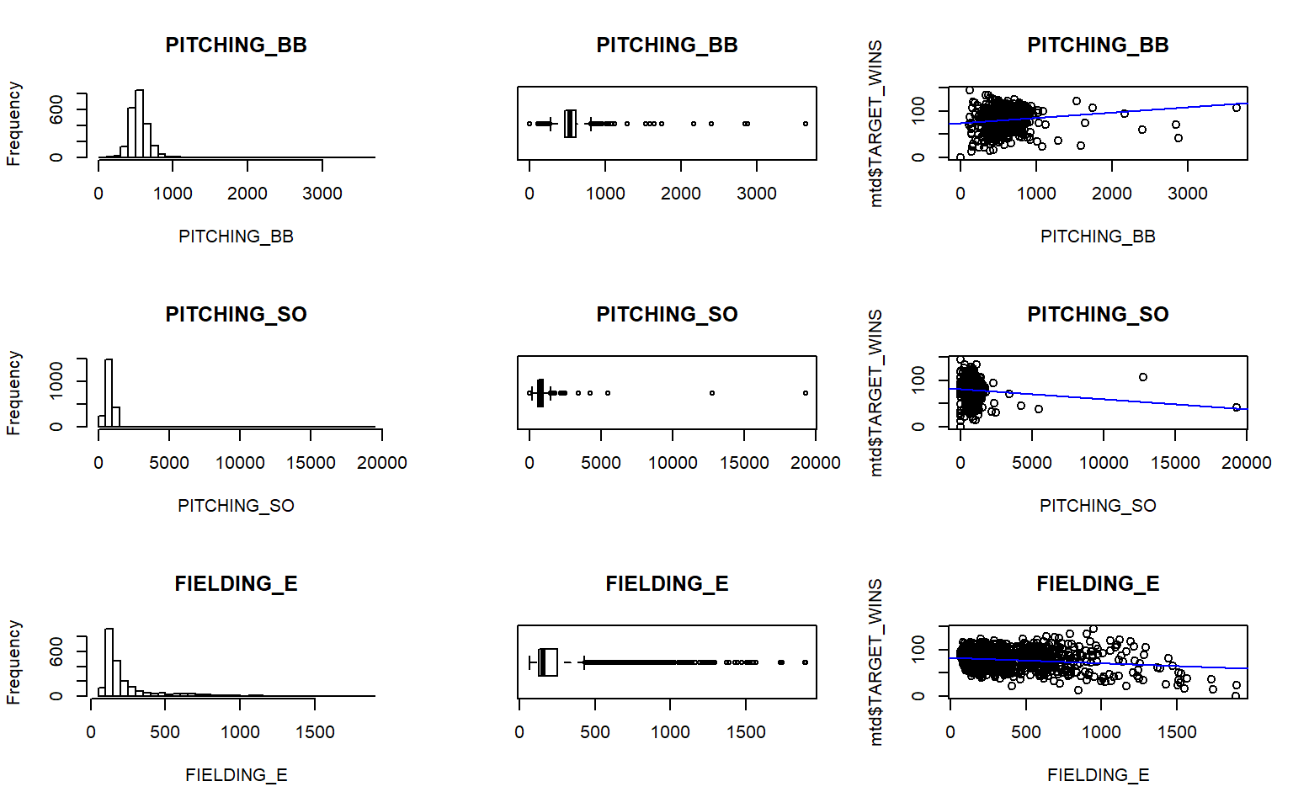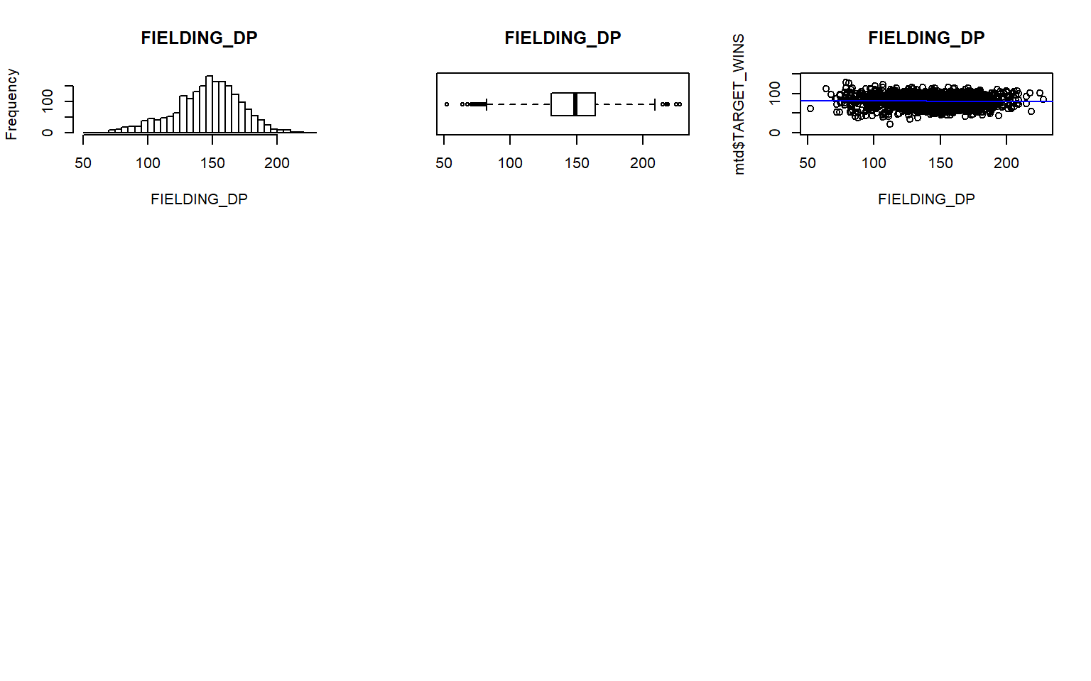

As can be seen from above histogram, boxplot and scatter plot with regression line shows the spread of the data points. More than half of the variables show skewness. A box-cox transformation may help to mitigate the skewness. Plot also shows very few variables are normally distributed.

**3.7 Missing or NA Values**

We are trying to see how many NA is present in the dataset.

| **variable** | **n** | **percent** |
| --- | --- | --- |
| BATTING_HBP | 2085 | 92% |
| BASERUN_CS | 772 | 34% |
| FIELDING_DP | 286 | 13% |
| BASERUN_SB | 131 | 5.8% |
| BATTING_SO | 102 | 4.5% |
| PITCHING_SO | 102 | 4.5% |

The variable BATTING_HBP (hit by pitcher) is missing over 90% of it’s data.

**3.8 Zero Values**

Code

| **variable** | **n** | **percent** |
| --- | --- | --- |
| BATTING_SO | 20 | 0.9% |
| PITCHING_SO | 20 | 0.9% |
| BATTING_HR | 15 | 0.7% |
| PITCHING_HR | 15 | 0.7% |
| BASERUN_SB | 2 | 0.1% |
| BATTING_3B | 2 | 0.1% |
| BASERUN_CS | 1 | 0% |
| BATTING_BB | 1 | 0% |
| PITCHING_BB | 1 | 0% |
| TARGET_WINS | 1 | 0% |

As can be inferred from above, there are very few zero values exists.

**3.9 Checking for outliers**

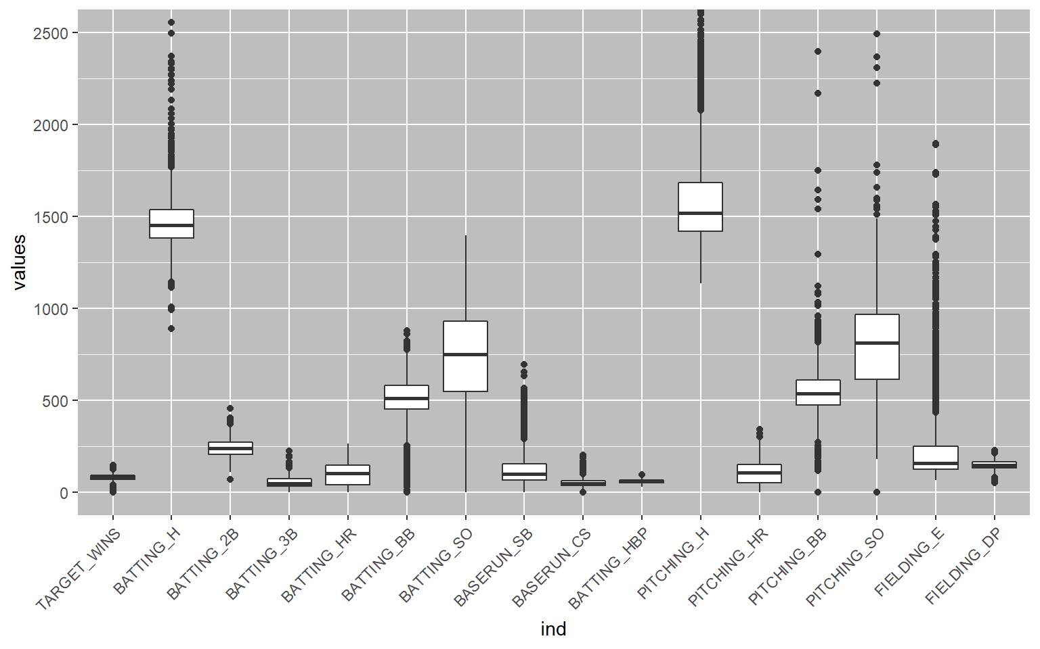

The box plots reveal that a great majority of the explanatory variables have high variances. Many of the medians and means are also not aligned which demonstrates the outliers’ effects.

The variance of some of the explanatory variables greatly exceeds the variance of the response “win” variable. The dataset has many outlines with some observations that are more extreme than the 1.5 * IQR of the box plot whiskers.

**3.10 Checking for skewness in the data**

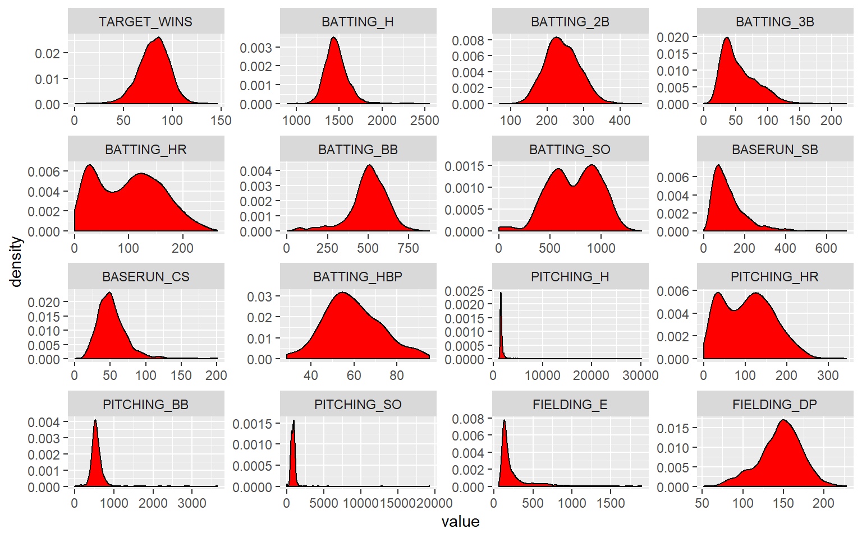

As per above, there are several variables like PITCHING_H, PITCHING_BB, PITCHING_SO and FIELDING_E are extremely skewed as there are many outliers.

**3.11 Finding correlations**

Below shows the comparative correlations between the 16 variables as it shows the correlation coefficients and thus find correlated variables. Whichever adhere to a fitted straight red line well, ie. change in synch with each other. If the points lie close to the line but the line is curved, it’s good nonlinear association and one can still be defined by other. Each individual plot shows the relationship between the variable in the horizontal vs the vertical of the grid. Each individual plot shows the relationship between the variable in the horizontal vs the vertical of the grid, whereas the diagonal is showing a histogram of each variable.

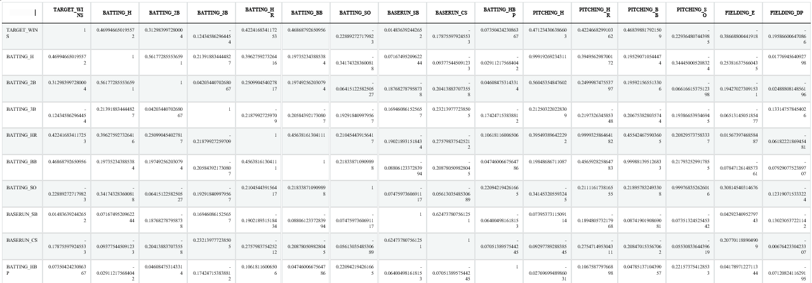

Showing 1 to 10 of 16 entries

Previous12Next

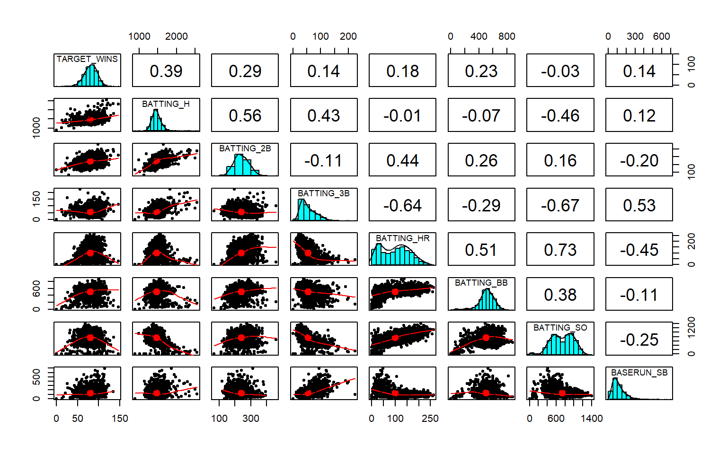

As can be seen from above, TARGET_WINS vs BATTING_2B is continuous and hence correlated and so is BATTING_BB and BATTING_HR.

Code

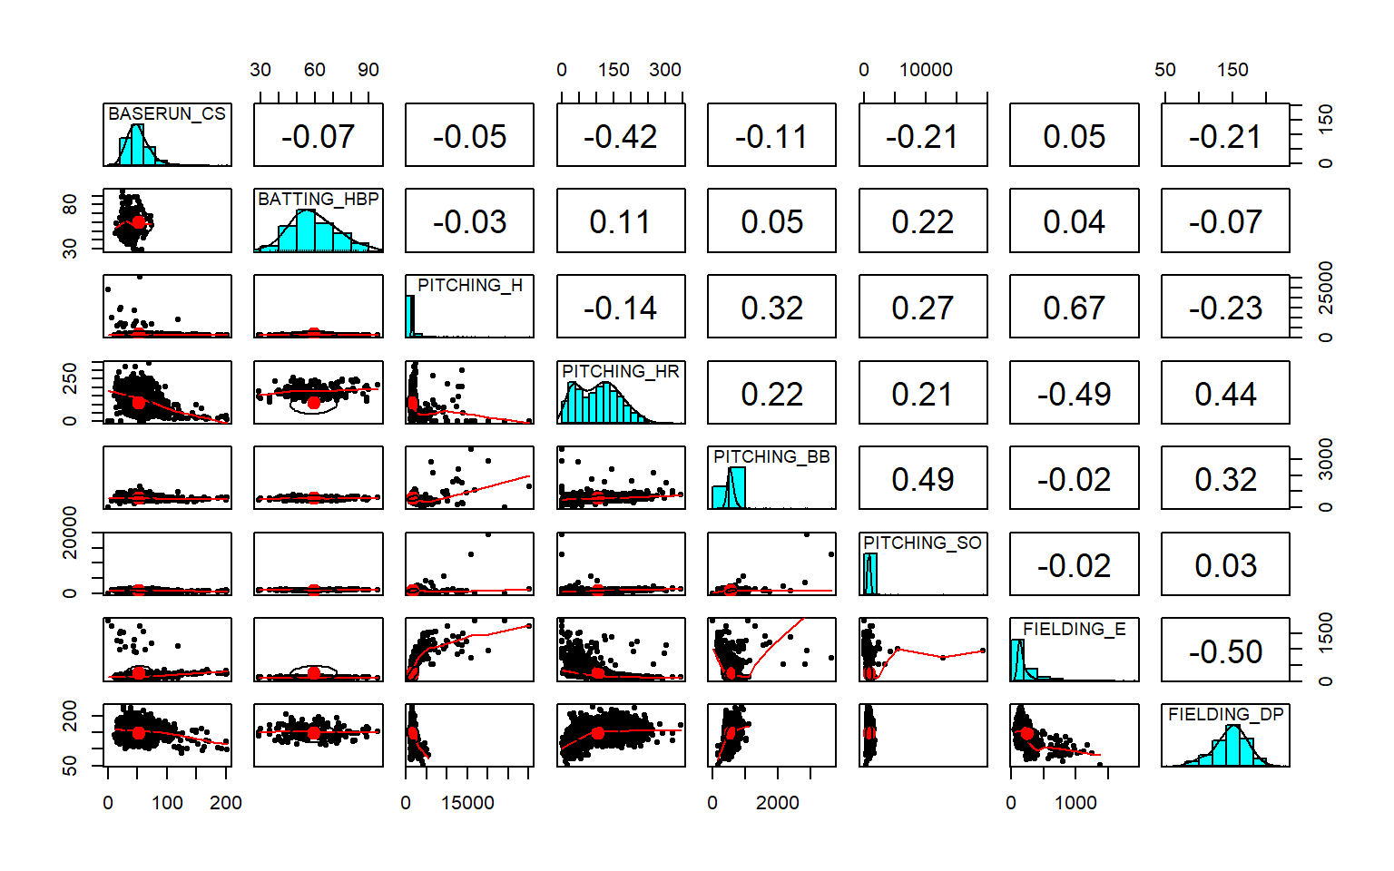

As can be seen from above, BASERUN_CS vs BATTING_HBP is continuous and hence correlated whereas PITCHING_SO and FIELDING_E is not correlated at all.

Code

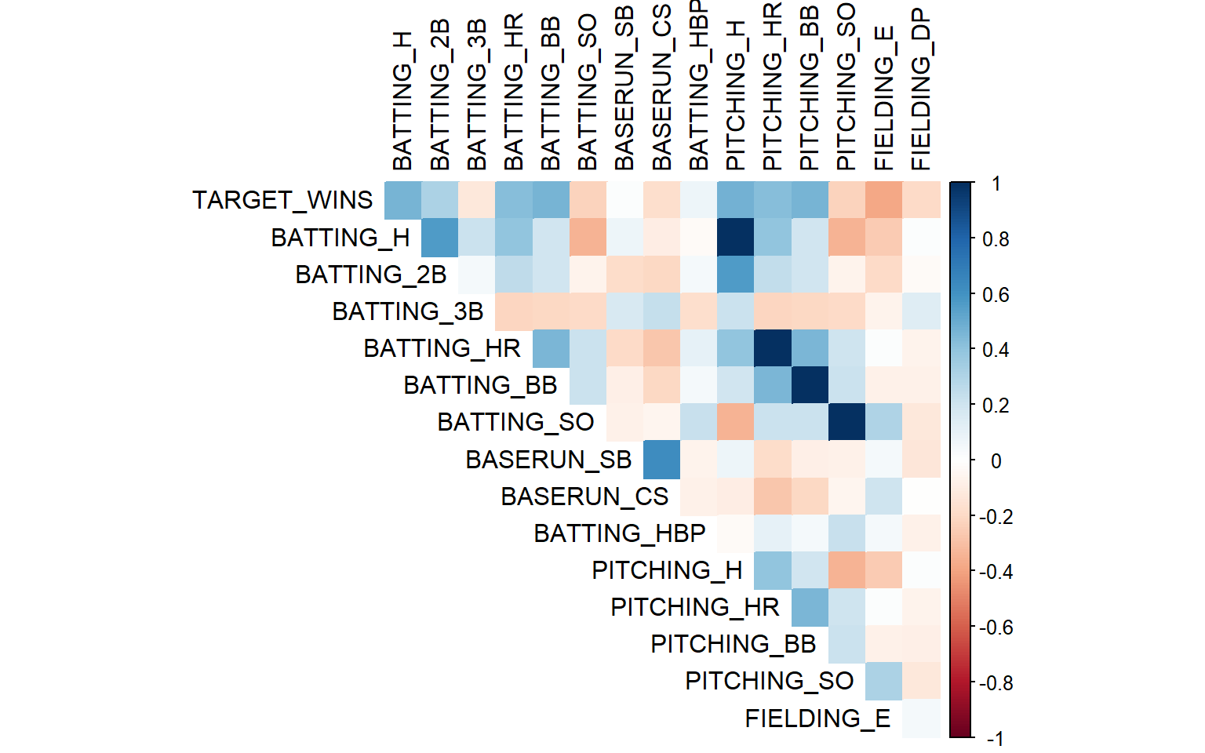

Also, there are some negatively correlated variables. According to the correlation heatmap, the values that correspond most positively are BATTING_H, BATTING_2B, BATTING_HR, BATTING_BB, PITCHING_H, PITCHING_HR, and PITCHING_BB.

Code

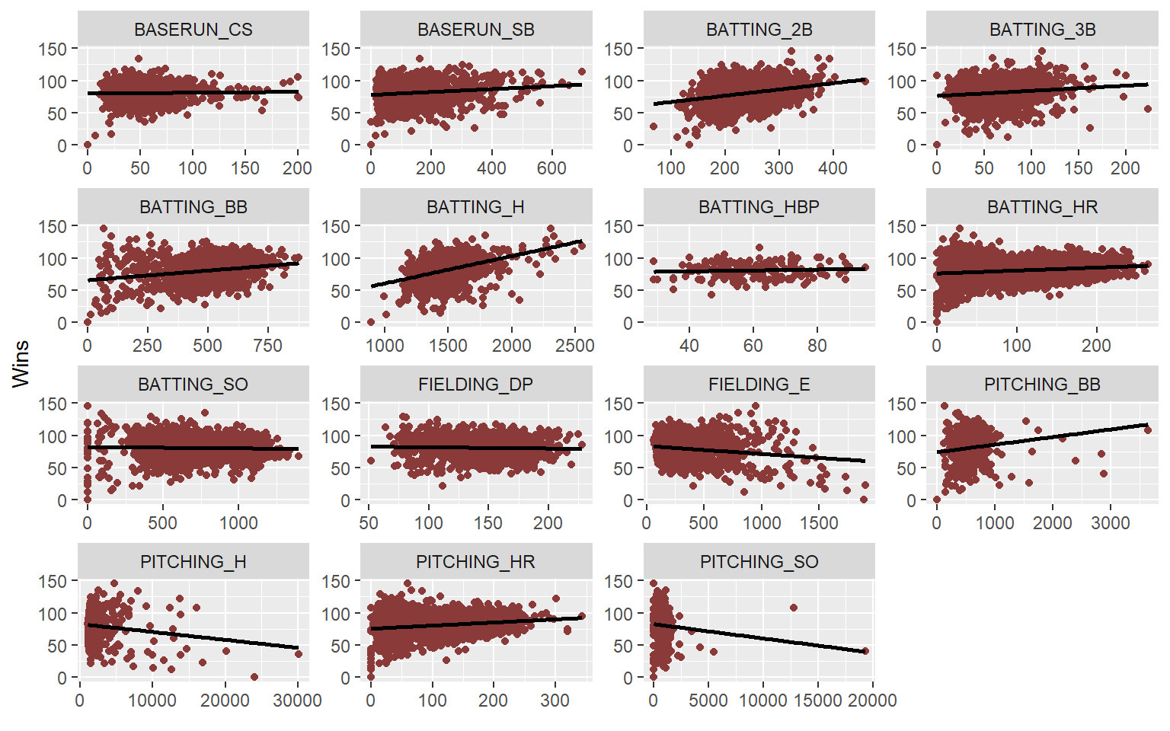

Above shows how the data is distributed when compared to the linear regression. Clearly, PITCHING_H and PITCHING_SO are highly heteroscedastic. Comparatively, BATTING_HBP is most homoscedastic.

Code

## TARGET_WINS BATTING_H

## TARGET_WINS 1.00000000 0.46994665

## BATTING_H 0.46994665 1.00000000

## BATTING_2B 0.31298400 0.56177286

## BATTING_3B -0.12434586 0.21391883

## BATTING_HR 0.42241683 0.39627593

## BATTING_BB 0.46868793 0.19735234

## BATTING_SO -0.22889273 -0.34174328

## BASERUN_SB 0.01483639 0.07167495

## BASERUN_CS -0.17875598 -0.09377545

## BATTING_HBP 0.07350424 -0.02911218

## PITCHING_H 0.47123431 0.99919269

## PITCHING_HR 0.42246683 0.39495630

## PITCHING_BB 0.46839882 0.19529071

## PITCHING_SO -0.22936481 -0.34445001

## FIELDING_E -0.38668800 -0.25381638

## FIELDING_DP -0.19586601 0.01776946

Above shows the correlation coefficient of each variable compared to TARGET_WINS and BATTING_H.

**3.12 Missing value by Graph**

Here will see how much of data is missing in each predictor.

Code

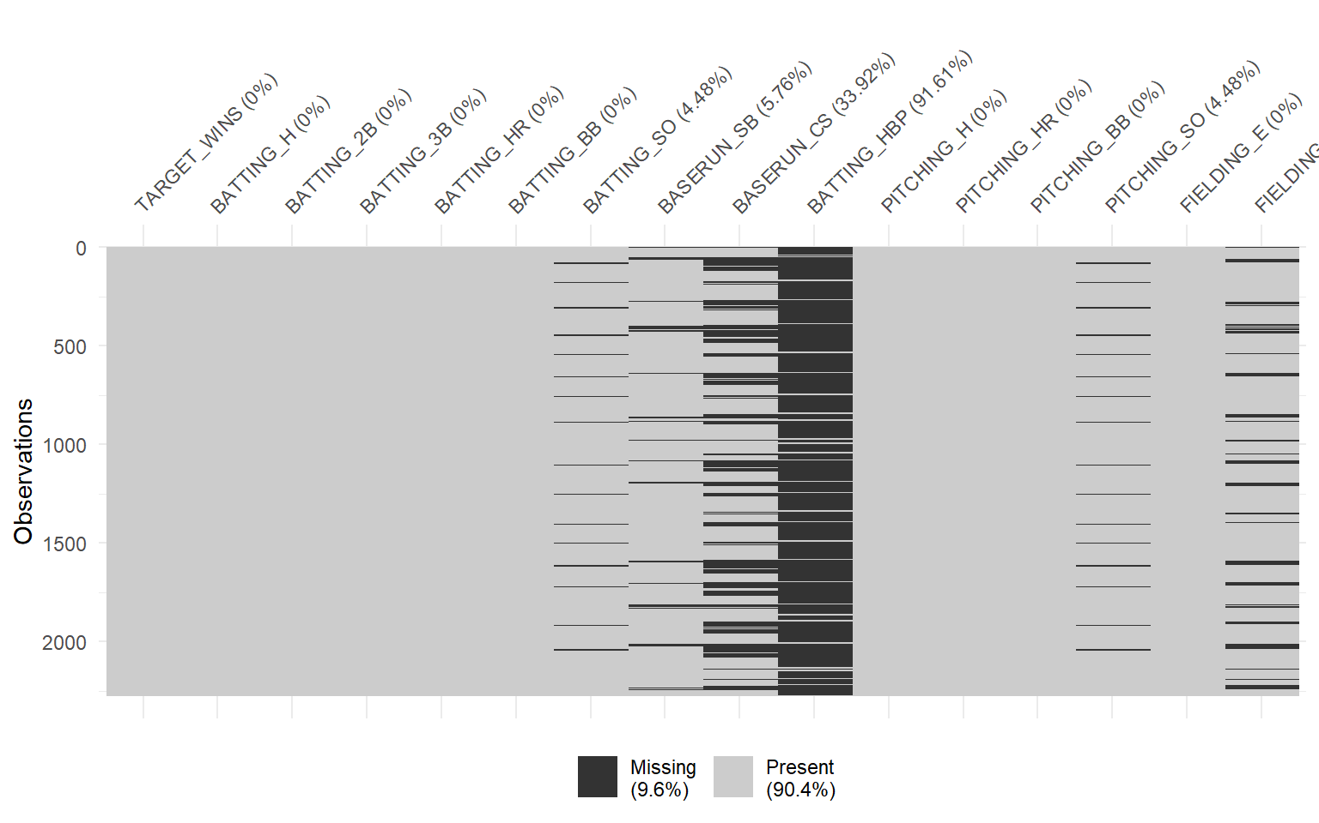

Here from the plots we can see outliers in PITCHING_H,PITCHING_BB and PITCHING_SO

Also, since BATTING_H is a combination of BATTING_2B, BATTING_3B, BATTING_HR (and also includes batted singles), we will create a new variable BATTING_1B equaling BATTING_H - BATTING_2B - BATTING_3B - BATTING_HR and after creating this we will remove BATTING_H

**3.13 Initial Observations**

* *Response variable (TARGET_WINS) looks to be normally distributed which means there are good teams, bad teams as well as average teams.*
* *There are also quite a few variables with missing values. We may need to deal with these in order to have the largest data set possible for modeling.*
* *A couple variables are bimodal (TEAM_BATTING_HR, TEAM_BATTING_SO, TEAM_PITCHING_HR). This may be a challenge as some of them are missing values and that may be a challenge in filling in missing values.*
* *Some variables are right skewed (TEAM_BASERUN_CS, TEAM_BASERUN_SB, etc.). This might support the good team theory. It may also introduce non-normally distributed residuals in the model. We shall see.*
* *Dataset covers a wide time period spanning across multiple “eras” of baseball.*

**4 DATA PREPARATION**

**4.1 Fixing Missing/Zero Values**

* Remove the invalid data and prepare it for imputation.
* We could “discard” the TEAM_BATTING_HBP,due to the high percentage of missing data; particularly, replacing it by “ZERO” should not be advisable since the minimum value recorded is 29 and replacing it with a median value would not be much helpful due to high percentage of missing values. *We decided not to consider this variable for our study*.
* A typical professional league baseball game has 9 innings (extra innings come to play in the event of a tie) in length, and in each inning one can only pitch 3 strikeouts. There have been a maximum of 27 potential strikeouts upto a maximum of by 162 games for each of the 30 teams in the American League (AL) and National League (NL), played over approximately six months in Major League Baseball (MLB) season. Therefore having more than 4374 strikeouts (9x3x162) is not possible. Incidentally, the maximum strikeouts in any baseball season has been 513 by Matt Kilroy in the year 1886 as part of Baltimore Orioles within American Association League.

Code

**4.2 Imputing the values using KNN**

*K-Nearest Neighbors (KNN)* : K Nearest Neighbors is an algorithm that is useful for matching a point with its closest k neighbors in a multi-dimensional space. Therefore, a point value can be approximated by the values of the points that are closest to it, based on other variables.

The KNN imputation algorithm helps in imputing missing data by finding the k closest neighbors to the observation with missing data and then imputing them based on the the non-missing values in the neighbors. Most common method used for KNN is weighted mean

Code

As can be observed from above KNN imputation (result table below ), the models did not behave favorably resulting in high RMSE and low R squared which results in poor prediction due to generation of highly correlated data.

| **Model Name** | **RMSE** | **R^2** |
| --- | --- | --- |
| model1 | 13.1079 | 0.271328 |
| model2 | 13.2033 | 0.26092 |
| model3 | 13.1079 | 0.27133 |
| model4 | 13.3301 | 0.24664 |
| model5 | 13.2601 | 0.25328 |
| model6 | 13.0805 | 0.27403 |

Since BATTING_H is a combination of BATTING_2B, BATTING_3B, BATTING_HR (and also includes batted singles), we will create a new variable BATTING_1B equaling BATTING_H - BATTING_2B - BATTING_3B - BATTING_HR and after creating this we will remove BATTING_H

Code

**5 BUILD MODELS**

*Kitchen Sink Model* : With all variables to determine the base model provided. This would allow to see which variables are significant in our dataset, and allows to make other models based on that.

Code

**5.1 Model 1 (Kitchen Sink Model/Backward Elimination)**

Predictor: All Variables Response : TARGET_WINS

Code

##

## Call:

## lm(formula = TARGET_WINS ~ ., data = moneyball_train)

##

## Residuals:

## Min 1Q Median 3Q Max

## -30.0724 -6.5828 -0.1407 6.4786 28.3847

##

## Coefficients: (1 not defined because of singularities)

## Estimate Std. Error t value Pr(>|t|)

## (Intercept) 58.53113 7.79100 7.513 1.25e-13 ***

## BATTING_H 0.01653 0.02346 0.704 0.481330

## BATTING_2B -0.07540 0.01100 -6.854 1.23e-11 ***

## BATTING_3B 0.17325 0.02552 6.789 1.90e-11 ***

## BATTING_HR 0.13176 0.09460 1.393 0.163944

## BATTING_BB 0.02796 0.05440 0.514 0.607397

## BATTING_SO 0.01254 0.02769 0.453 0.650670

## BASERUN_SB 0.03694 0.01026 3.600 0.000334 ***

## BASERUN_CS 0.05115 0.02196 2.329 0.020032 *

## PITCHING_H 0.01747 0.02210 0.791 0.429325

## PITCHING_HR -0.02926 0.09070 -0.323 0.747075

## PITCHING_BB 0.01110 0.05237 0.212 0.832216

## PITCHING_SO -0.03241 0.02645 -1.225 0.220789

## FIELDING_E -0.16207 0.01230 -13.176 < 2e-16 ***

## FIELDING_DP -0.10625 0.01545 -6.875 1.07e-11 ***

## BATTING_1B NA NA NA NA

## ---

## Signif. codes: 0 '***' 0.001 '**' 0.01 '*' 0.05 '.' 0.1 ' ' 1

##

## Residual standard error: 9.469 on 1037 degrees of freedom

## (543 observations deleted due to missingness)

## Multiple R-squared: 0.4421, Adjusted R-squared: 0.4346

## F-statistic: 58.7 on 14 and 1037 DF, p-value: < 2.2e-16

Code

It does a fairly good job predicting, but there are a lot of variables that are not statistically significant. We see the that P-value is less than .05 which makes it one of the possible model but not all the coefficients of the model1 are significant.

**5.1.1 Plot Model1**

Code

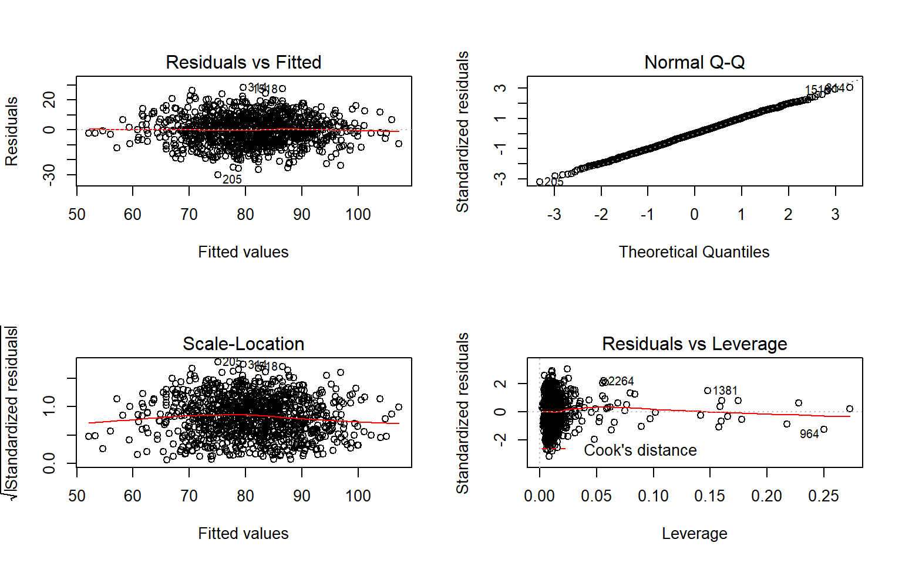

From the above residual plots let’s analyze if the assumptions of our model is correct or not:

1. The variability of the points is approximately the same in the mid values of x with the decrese of variations towards the two end points which depicts that the plot is unbaised and homoscedastic except for few outliers.
2. Normal q-q plot fulfills the assumptions of normality.

But since few coefficients of the model are not significant, let’s see if assumptions of other models are true.

**5.2 Model 2 : Simple Model**

With only the significant variables: Pick variables that had high correlations and include the pitching variables

Predictor: BATTING_H + BATTING_3B + BATTING_HR + BATTING_BB + BATTING_SO + BASERUN_SB + PITCHING_SO + PITCHING_H + PITCHING_SO + FIELDING_E + FIELDING_DP Response : TARGET_WINS

Code

##

## Call:

## lm(formula = TARGET_WINS ~ BATTING_H + BATTING_3B + BATTING_HR +

## BATTING_BB + BATTING_SO + BASERUN_SB + PITCHING_SO + PITCHING_H +

## PITCHING_SO + FIELDING_E + FIELDING_DP, data = moneyball_train)

##

## Residuals:

## Min 1Q Median 3Q Max

## -31.633 -7.407 0.103 7.218 29.771

##

## Coefficients:

## Estimate Std. Error t value Pr(>|t|)

## (Intercept) 73.346701 6.624503 11.072 < 2e-16 ***

## BATTING_H -0.036127 0.012857 -2.810 0.005032 **

## BATTING_3B 0.201222 0.022342 9.007 < 2e-16 ***

## BATTING_HR 0.114499 0.010869 10.535 < 2e-16 ***

## BATTING_BB 0.032347 0.003796 8.522 < 2e-16 ***

## BATTING_SO 0.048172 0.020693 2.328 0.020072 *

## BASERUN_SB 0.074635 0.006672 11.186 < 2e-16 ***

## PITCHING_SO -0.071270 0.019581 -3.640 0.000284 ***

## PITCHING_H 0.043819 0.011707 3.743 0.000190 ***

## FIELDING_E -0.111738 0.008436 -13.245 < 2e-16 ***

## FIELDING_DP -0.105429 0.014630 -7.206 9.77e-13 ***

## ---

## Signif. codes: 0 '***' 0.001 '**' 0.01 '*' 0.05 '.' 0.1 ' ' 1

##

## Residual standard error: 10.29 on 1286 degrees of freedom

## (298 observations deleted due to missingness)

## Multiple R-squared: 0.3949, Adjusted R-squared: 0.3902

## F-statistic: 83.92 on 10 and 1286 DF, p-value: < 2.2e-16

Code

For model 2, since we have only considered significant values from model 1, Multiple R-squared value is 0.39 which is a good representation that our model fits the data.

This model also does a good job predicting, and all variables are statistically significant.

**5.2.1 Plot Model 2**

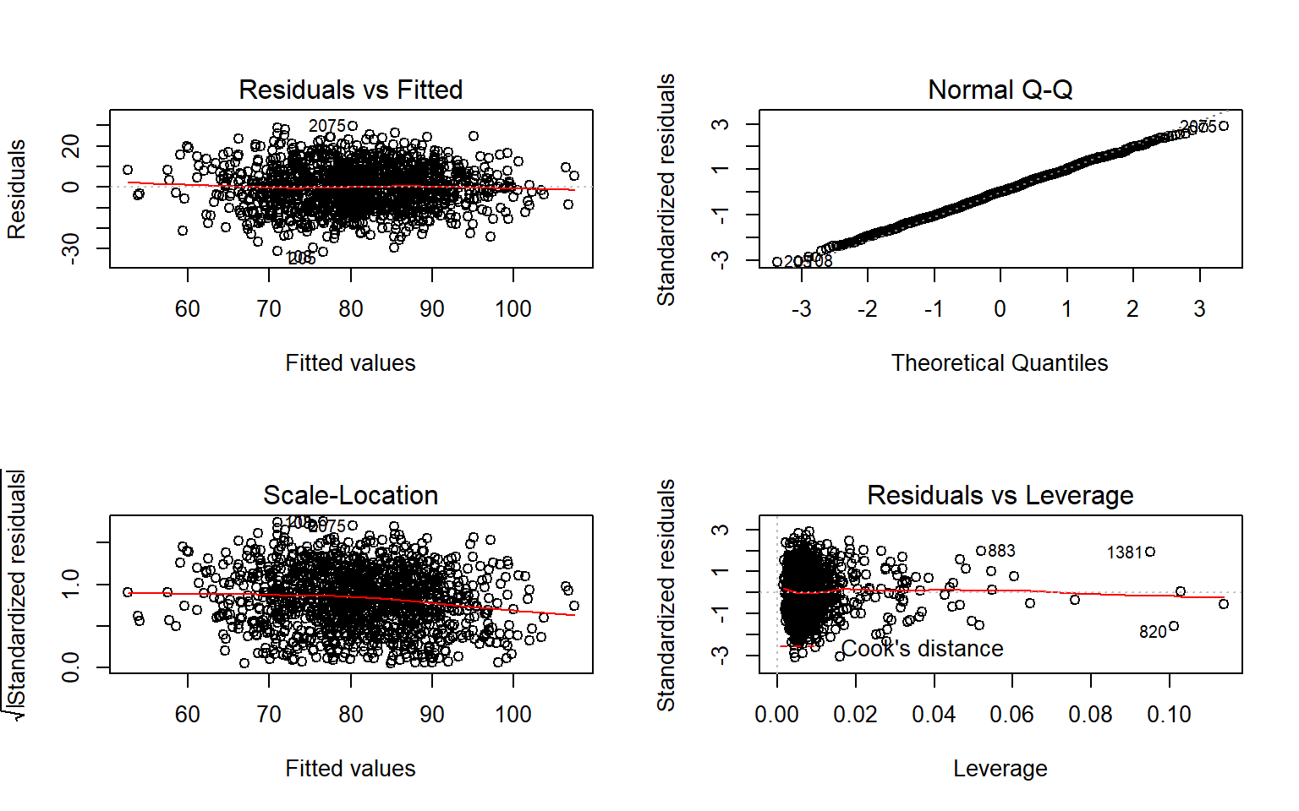

From the above residual plots let’s analyze if the assumptions of our model is correct or not:

1. The variability of the points is approximately the same throughout the values of x which depicts that this plot is also unbiased and homoscedastic with very few(minimum) outliers.
2. Normal q-q plot fulfills the assumptions of normality.

From the above points , assumptions of model 2 is true, let’s see if assumptions of our next models are true.

**5.3 Model 3 : Higher Order Stepwise Regression**

Only taking the variable from the Model1 that are significant.

Predictor: BATTING_2B+BATTING_3B+BASERUN_SB+BASERUN_CS+FIELDING_E+FIELDING_DP  
Response : TARGET_WINS

##

## Call:

## lm(formula = TARGET_WINS ~ BATTING_2B + BATTING_3B + BASERUN_SB +

## BASERUN_CS + FIELDING_E + FIELDING_DP, data = moneyball_train)

##

## Residuals:

## Min 1Q Median 3Q Max

## -30.0056 -7.9628 -0.3434 8.0241 30.3356

##

## Coefficients:

## Estimate Std. Error t value Pr(>|t|)

## (Intercept) 93.226932 4.171175 22.350 <2e-16 ***

## BATTING_2B 0.019018 0.008810 2.159 0.0311 *

## BATTING_3B 0.273238 0.025450 10.736 <2e-16 ***

## BASERUN_SB 0.018523 0.011820 1.567 0.1174

## BASERUN_CS 0.007483 0.025892 0.289 0.7726

## FIELDING_E -0.169187 0.013894 -12.177 <2e-16 ***

## FIELDING_DP -0.043599 0.018145 -2.403 0.0164 *

## ---

## Signif. codes: 0 '***' 0.001 '**' 0.01 '*' 0.05 '.' 0.1 ' ' 1

##

## Residual standard error: 11.44 on 1045 degrees of freedom

## (543 observations deleted due to missingness)

## Multiple R-squared: 0.1794, Adjusted R-squared: 0.1747

## F-statistic: 38.08 on 6 and 1045 DF, p-value: < 2.2e-16

Predictor: BATTING_3B + FIELDING_E + BATTING_2B + FIELDING_DP  
Response : TARGET_WINS

##

## Call:

## lm(formula = TARGET_WINS ~ BATTING_3B + FIELDING_E + BATTING_2B +

## FIELDING_DP, data = moneyball_train)

##

## Residuals:

## Min 1Q Median 3Q Max

## -41.154 -9.095 0.359 8.972 47.276

##

## Coefficients:

## Estimate Std. Error t value Pr(>|t|)

## (Intercept) 73.11824 3.17547 23.026 < 2e-16 ***

## BATTING_3B 0.15080 0.01793 8.411 < 2e-16 ***

## FIELDING_E -0.02936 0.00371 -7.913 5.08e-15 ***

## BATTING_2B 0.06870 0.00816 8.418 < 2e-16 ***

## FIELDING_DP -0.07547 0.01579 -4.780 1.94e-06 ***

## ---

## Signif. codes: 0 '***' 0.001 '**' 0.01 '*' 0.05 '.' 0.1 ' ' 1

##

## Residual standard error: 13.17 on 1396 degrees of freedom

## (194 observations deleted due to missingness)

## Multiple R-squared: 0.1159, Adjusted R-squared: 0.1134

## F-statistic: 45.75 on 4 and 1396 DF, p-value: < 2.2e-16

Code

As we see above, in Model3a in which “BATTING_3B,FIELDING_E ,BATTING_2B,FIELDING_DP” are significant and are considered in the model. We get Multiple R-squared as 0.17.

In Model3b we chose “BATTING_3B + FIELDING_E + BATTING_2B + FIELDING_DP” as they are significant coefficients in model3a. We get Multiple R-squared as 0.11

Further reducing the variables(TEAM_PITCHING_SO and TEAM_BATTING_SO are having high correlation, TEAM_BATTING_H and TEAM_PITCHING_H are also having high correlation, TEAM_BATTING_SO and TEAM_PITCHING_SO are also having high correlation):

Predictor: BATTING_1B + BATTING_2B + BATTING_3B + BATTING_HR + BATTING_BB + BATTING_SO + BASERUN_SB + BASERUN_CS + PITCHING_H + PITCHING_HR + PITCHING_BB + PITCHING_SO + FIELDING_E + FIELDING_DP + Quadratic  
Response : TARGET_WINS

Code

##

## Call:

## lm(formula = TARGET_WINS ~ BATTING_1B + BATTING_2B + BATTING_3B +

## BATTING_HR + BATTING_BB + BATTING_SO + BASERUN_SB + BASERUN_CS +

## PITCHING_H + PITCHING_HR + PITCHING_BB + PITCHING_SO + FIELDING_E +

## FIELDING_DP + +I(BATTING_1B^2) + I(BATTING_2B^2) + I(BATTING_3B^2) +

## I(BATTING_HR^2) + I(BATTING_BB^2) + I(BATTING_SO^2) + +I(BASERUN_SB^2) +

## I(BASERUN_CS^2) + +I(PITCHING_H^2) + I(PITCHING_HR^2) + I(PITCHING_BB^2) +

## I(PITCHING_SO^2) + +I(FIELDING_E^2) + I(FIELDING_DP^2) +

## +I(BATTING_2B^3) + I(BATTING_3B^3) + I(BATTING_HR^3) + I(BATTING_BB^3) +

## I(BATTING_SO^3) + +I(BASERUN_SB^3) + I(BASERUN_CS^3) + +I(PITCHING_H^3) +

## I(PITCHING_HR^3) + I(PITCHING_BB^3) + I(PITCHING_SO^3) +

## +I(FIELDING_E^3) + I(FIELDING_DP^3) + +I(BATTING_1B^3) +

## I(BATTING_2B^4) + I(BATTING_3B^4) + I(BATTING_HR^4) + I(BATTING_BB^4) +

## I(BATTING_SO^4) + +I(BASERUN_SB^4) + I(BASERUN_CS^4) + +I(PITCHING_H^4) +

## I(PITCHING_HR^4) + I(PITCHING_BB^4) + I(PITCHING_SO^4) +

## +I(FIELDING_E^4) + I(FIELDING_DP^4) + I(BATTING_1B^4), data = moneyball_train)

##

## Residuals:

## Min 1Q Median 3Q Max

## -29.7539 -6.1490 0.0937 6.2226 25.7811

##

## Coefficients:

## Estimate Std. Error t value Pr(>|t|)

## (Intercept) 6.434e+02 2.086e+03 0.308 0.7578

## BATTING_1B -4.275e-02 7.965e+00 -0.005 0.9957

## BATTING_2B 1.593e+00 3.124e+00 0.510 0.6103

## BATTING_3B 4.008e-02 5.314e-01 0.075 0.9399

## BATTING_HR 7.473e-02 3.574e+00 0.021 0.9833

## BATTING_BB -3.481e+00 4.281e+00 -0.813 0.4163

## BATTING_SO 4.714e+00 2.646e+00 1.782 0.0751 .

## BASERUN_SB -1.475e-01 1.446e-01 -1.020 0.3079

## BASERUN_CS 3.247e-01 2.786e-01 1.166 0.2441

## PITCHING_H -1.155e+00 1.608e+00 -0.718 0.4729

## PITCHING_HR -4.535e-01 3.363e+00 -0.135 0.8928

## PITCHING_BB 1.707e+00 4.053e+00 0.421 0.6737

## PITCHING_SO -4.704e+00 2.483e+00 -1.895 0.0584 .

## FIELDING_E 9.206e-01 7.065e-01 1.303 0.1928

## FIELDING_DP 4.511e+00 5.613e+00 0.804 0.4218

## I(BATTING_1B^2) -8.511e-04 1.115e-02 -0.076 0.9392

## I(BATTING_2B^2) -9.045e-03 1.856e-02 -0.487 0.6261

## I(BATTING_3B^2) -4.834e-03 1.438e-02 -0.336 0.7368

## I(BATTING_HR^2) -2.382e-03 1.894e-02 -0.126 0.8999

## I(BATTING_BB^2) 3.664e-03 6.098e-03 0.601 0.5480

## I(BATTING_SO^2) -3.707e-03 2.208e-03 -1.678 0.0936 .

## I(BASERUN_SB^2) 1.996e-03 1.811e-03 1.102 0.2707

## I(BASERUN_CS^2) -6.253e-03 5.490e-03 -1.139 0.2550

## I(PITCHING_H^2) 1.182e-03 1.481e-03 0.799 0.4247

## I(PITCHING_HR^2) 5.229e-03 1.657e-02 0.316 0.7523

## I(PITCHING_BB^2) 8.306e-04 5.222e-03 0.159 0.8737

## I(PITCHING_SO^2) 3.715e-03 1.921e-03 1.933 0.0535 .

## I(FIELDING_E^2) -9.853e-03 6.458e-03 -1.526 0.1274

## I(FIELDING_DP^2) -4.347e-02 5.435e-02 -0.800 0.4240

## I(BATTING_2B^3) 1.744e-05 4.819e-05 0.362 0.7176

## I(BATTING_3B^3) 7.869e-05 1.626e-04 0.484 0.6285

## I(BATTING_HR^3) 9.244e-06 5.800e-05 0.159 0.8734

## I(BATTING_BB^3) -2.801e-06 5.302e-06 -0.528 0.5975

## I(BATTING_SO^3) 1.650e-06 1.107e-06 1.491 0.1362

## I(BASERUN_SB^3) -8.207e-06 9.124e-06 -0.899 0.3686

## I(BASERUN_CS^3) 4.770e-05 4.287e-05 1.112 0.2662

## I(PITCHING_H^3) -4.353e-07 5.801e-07 -0.750 0.4533

## I(PITCHING_HR^3) -1.968e-05 4.662e-05 -0.422 0.6730

## I(PITCHING_BB^3) -2.120e-06 3.931e-06 -0.539 0.5898

## I(PITCHING_SO^3) -1.679e-06 8.729e-07 -1.924 0.0547 .

## I(FIELDING_E^3) 3.783e-05 2.515e-05 1.504 0.1328

## I(FIELDING_DP^3) 1.749e-04 2.310e-04 0.757 0.4493

## I(BATTING_1B^3) 9.316e-07 6.912e-06 0.135 0.8928

## I(BATTING_2B^4) -1.013e-08 4.626e-08 -0.219 0.8268

## I(BATTING_3B^4) -3.432e-07 6.361e-07 -0.539 0.5897

## I(BATTING_HR^4) -1.270e-08 7.269e-08 -0.175 0.8614

## I(BATTING_BB^4) 1.074e-09 1.949e-09 0.551 0.5819

## I(BATTING_SO^4) -2.990e-10 2.352e-10 -1.271 0.2040

## I(BASERUN_SB^4) 1.164e-08 1.552e-08 0.750 0.4534

## I(BASERUN_CS^4) -1.111e-07 1.118e-07 -0.994 0.3202

## I(PITCHING_H^4) 5.729e-11 8.340e-11 0.687 0.4923

## I(PITCHING_HR^4) 2.373e-08 5.223e-08 0.454 0.6497

## I(PITCHING_BB^4) 9.361e-10 1.207e-09 0.775 0.4383

## I(PITCHING_SO^4) 3.076e-10 1.630e-10 1.888 0.0594 .

## I(FIELDING_E^4) -5.152e-08 3.514e-08 -1.466 0.1429

## I(FIELDING_DP^4) -2.518e-07 3.637e-07 -0.692 0.4888

## I(BATTING_1B^4) -3.103e-10 1.599e-09 -0.194 0.8462

## ---

## Signif. codes: 0 '***' 0.001 '**' 0.01 '*' 0.05 '.' 0.1 ' ' 1

##

## Residual standard error: 9.331 on 995 degrees of freedom

## (543 observations deleted due to missingness)

## Multiple R-squared: 0.4802, Adjusted R-squared: 0.4509

## F-statistic: 16.41 on 56 and 995 DF, p-value: < 2.2e-16

Code

**5.4 StepBack Model**

For StepBack Model, we have used MASS::stepAIC() function, which will generate the variables to create a system generated model. And as we see all the coefficients generated are significant.

Code

##

## Call:

## lm(formula = poly_call[2], data = moneyball_train)

##

## Residuals:

## Min 1Q Median 3Q Max

## -29.3740 -6.3034 -0.1952 6.2077 26.1001

##

## Coefficients:

## Estimate Std. Error t value Pr(>|t|)

## (Intercept) 3.188e+02 1.044e+02 3.055 0.00231 **

## BATTING_2B 8.256e-01 5.205e-01 1.586 0.11298

## BATTING_BB -3.382e+00 1.266e+00 -2.672 0.00767 **

## BATTING_SO 4.697e+00 1.527e+00 3.076 0.00215 **

## PITCHING_HR -3.189e-01 1.537e-01 -2.075 0.03820 *

## PITCHING_BB 2.486e+00 9.366e-01 2.654 0.00808 **

## PITCHING_SO -4.661e+00 1.444e+00 -3.227 0.00129 **

## I(BATTING_1B^2) -9.801e-04 3.806e-04 -2.575 0.01016 *

## I(BATTING_2B^2) -4.315e-03 2.036e-03 -2.119 0.03431 *

## I(BATTING_BB^2) 2.121e-03 8.614e-04 2.463 0.01396 *

## I(BATTING_SO^2) -3.678e-03 1.485e-03 -2.477 0.01341 *

## I(BASERUN_SB^2) 1.715e-04 3.723e-05 4.607 4.61e-06 ***

## I(PITCHING_H^2) 9.739e-05 2.992e-05 3.255 0.00117 **

## I(PITCHING_HR^2) 3.322e-03 1.587e-03 2.093 0.03658 *

## I(PITCHING_SO^2) 3.624e-03 1.293e-03 2.802 0.00517 **

## I(FIELDING_E^2) -9.489e-04 1.638e-04 -5.794 9.14e-09 ***

## I(FIELDING_DP^2) -1.756e-03 5.248e-04 -3.346 0.00085 ***

## I(BATTING_2B^3) 6.004e-06 2.623e-06 2.289 0.02227 *

## I(BATTING_3B^3) 6.187e-06 3.269e-06 1.893 0.05867 .

## I(BATTING_BB^3) -5.279e-07 2.966e-07 -1.780 0.07540 .

## I(BATTING_SO^3) 1.640e-06 8.379e-07 1.957 0.05061 .

## I(BASERUN_CS^3) 1.830e-06 7.946e-07 2.303 0.02145 *

## I(PITCHING_H^3) -2.172e-08 7.806e-09 -2.782 0.00550 **

## I(PITCHING_HR^3) -1.344e-05 6.971e-06 -1.928 0.05409 .

## I(PITCHING_BB^3) -1.602e-06 6.497e-07 -2.465 0.01385 *

## I(PITCHING_SO^3) -1.612e-06 6.526e-07 -2.470 0.01369 *

## I(FIELDING_E^3) 1.803e-06 5.822e-07 3.096 0.00201 **

## I(FIELDING_DP^3) 6.100e-06 2.188e-06 2.788 0.00540 **

## I(BATTING_1B^3) 1.125e-06 4.713e-07 2.387 0.01716 *

## I(BATTING_SO^4) -3.008e-10 1.936e-10 -1.553 0.12063

## I(PITCHING_HR^4) 1.703e-08 1.056e-08 1.612 0.10721

## I(PITCHING_BB^4) 8.033e-10 3.398e-10 2.364 0.01826 *

## I(PITCHING_SO^4) 2.908e-10 1.304e-10 2.230 0.02596 *

## I(BATTING_1B^4) -3.810e-10 1.636e-10 -2.329 0.02003 *

## ---

## Signif. codes: 0 '***' 0.001 '**' 0.01 '*' 0.05 '.' 0.1 ' ' 1

##

## Residual standard error: 9.267 on 1018 degrees of freedom

## (543 observations deleted due to missingness)

## Multiple R-squared: 0.4755, Adjusted R-squared: 0.4585

## F-statistic: 27.96 on 33 and 1018 DF, p-value: < 2.2e-16

For Model3, we take quadratic equation of predictors to analyze if multicollinearity exist . As we see, p-value is significant, so multicollinearity exist between the predictors.

**5.4.1 Plot Model3, Model3a, Model3b**

From the above residual plots let’s analyze if the assumptions of our model is correct or not:

**Model3:**

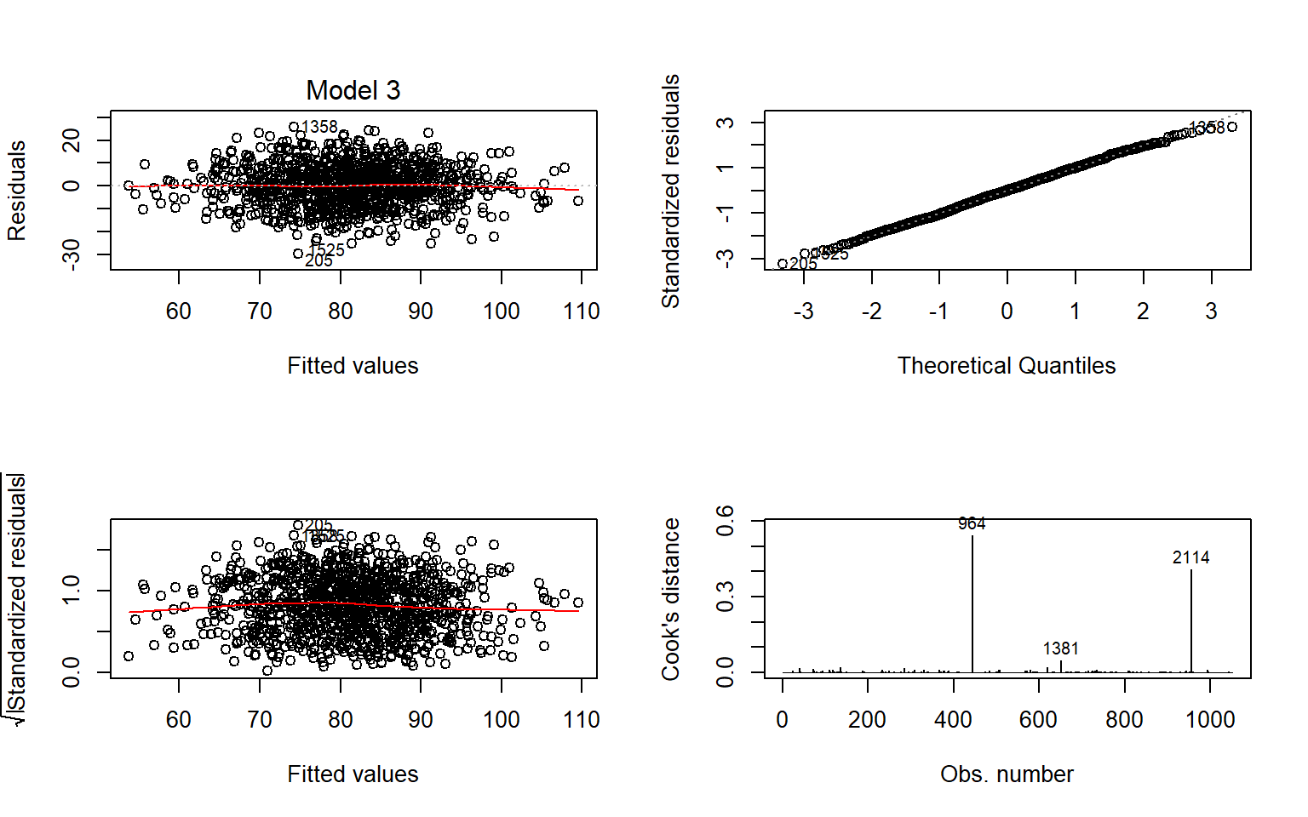

1. The variability of the points is approximately the same throughout the values of x with some outliers towards for the ends and the variability also differs in two ends. We can say that the model is homoscedastic.
2. Normal q-q plot fulfills the assumptions of normality with the exception of outliers.

**Model3a :**

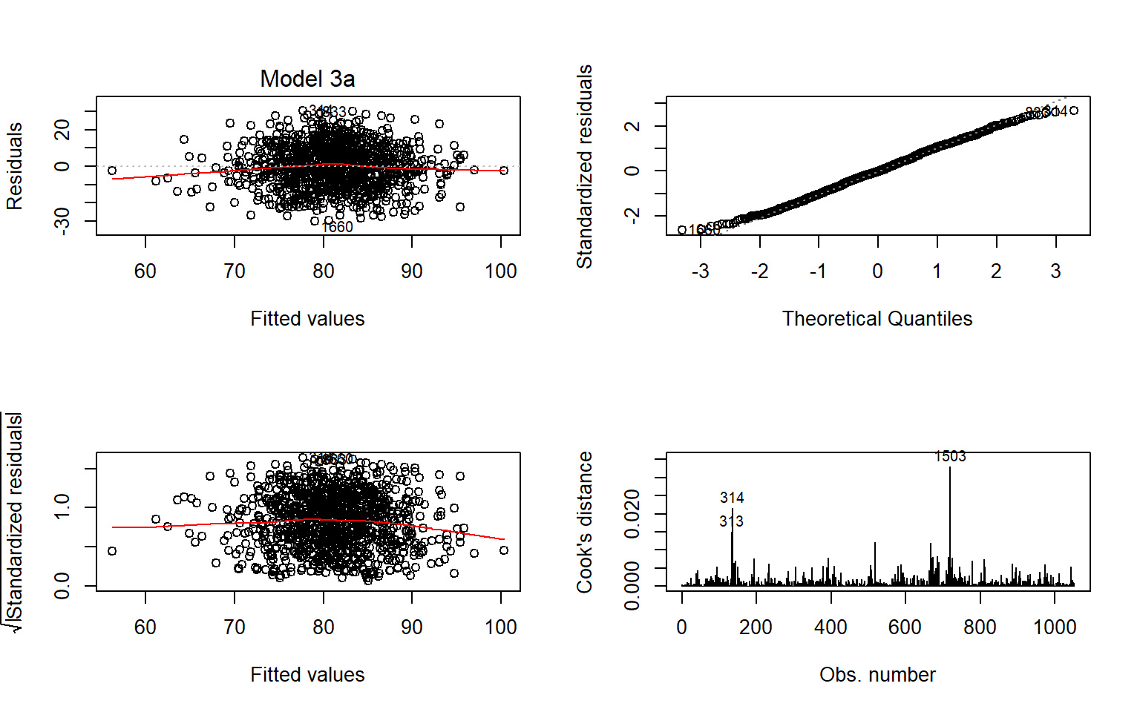

“BATTING_3B,FIELDING_E ,BATTING_2B,FIELDING_DP

1. Among the points scattered, variability of few points are not constant throughout.
2. Normal q-q plot fulfills the assumptions of normality with the exception of outliers.

**Model3b :**

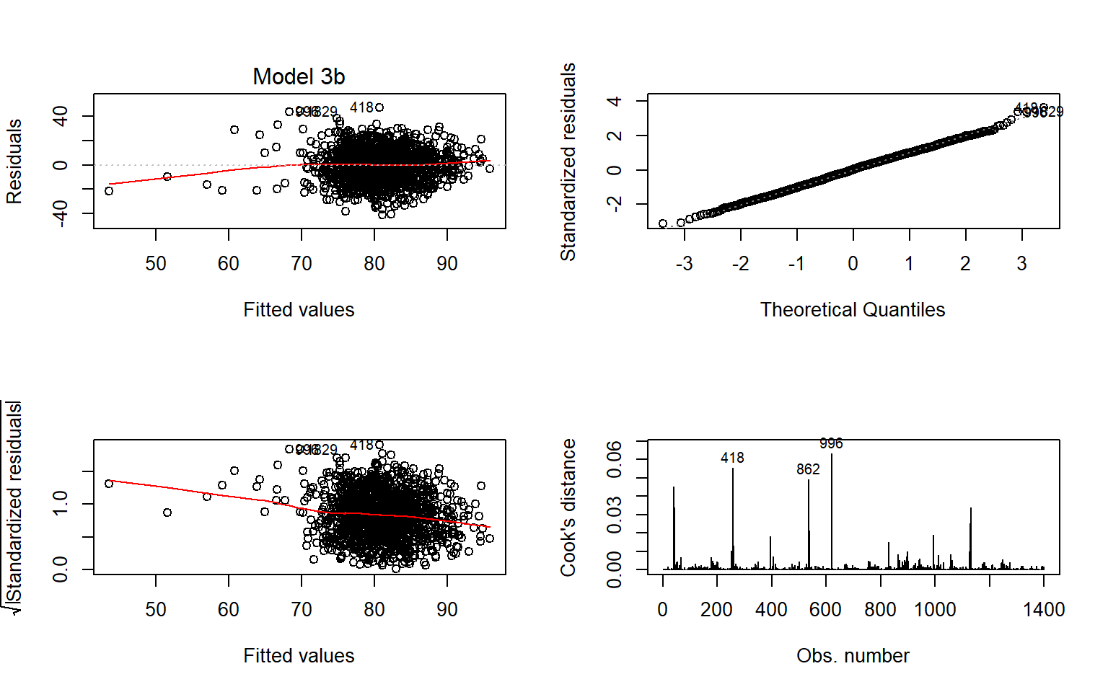

For Model3b, we choose the significant variables from model3a,

1. The points scattered does not have a constant variability, which shows that the assumptions of this model does not hold true

**6 SELECT MODELS**

We have created couple of models in the last step, let’s review the result for each of our model:

| **ModelName** | **Adjusted.R2** | **P.Value** | **AIC** | **Note** |
| --- | --- | --- | --- | --- |
| model1 | 0.4346 | 8.26675339500243e-121 | 7732.17046271654 | BATTING_2B,BATTING_3B,BASERUN_SB ,BASERUN_CS,FIELDING_E,FIELDING_DP |
| model2 | 0.3902 | 9.43169458989572e-133 | 9741.06557425804 | All are significant |
| model3a | 0.1747 | 6.064035000153e-42 | 8122.0744174421 | BATTING_3B,FIELDING_E ,BATTING_2B,FIELDING_DP are significant |
| model3b | 0.1134 | 3.7241282367616e-36 | 11207.2018569633 | All are significant |
| model3 | 0.4509 | 1.43731937269178e-105 | 7741.77841260617 | Nothing is significant |
| step_back | 0.4585 | 5.27149347920012e-119 | 7705.29597731889 | more vars significant |

Showing 1 to 7 of 7 entries

Previous1Next

**6.0.1 Multicollinearity**

Lets Evaluate if we have any multicollinearity in our model1s.Multicollinearity (also collinearity) is a statistical phenomenon in which two or more predictor variables in a multiple regression model are highly correlated, meaning that one can be linearly predicted from the others with a non-trivial degree of accuracy.

We will user alias function to detect the collinearity of all the predictor in the model1.

6.0.1.1 Model 1

Code

## Model :

## TARGET_WINS ~ BATTING_H + BATTING_2B + BATTING_3B + BATTING_HR +

## BATTING_BB + BATTING_SO + BASERUN_SB + BASERUN_CS + PITCHING_H +

## PITCHING_HR + PITCHING_BB + PITCHING_SO + FIELDING_E + FIELDING_DP +

## BATTING_1B

##

## Complete :

## (Intercept) BATTING_H BATTING_2B BATTING_3B BATTING_HR BATTING_BB

## BATTING_1B 0 1 -1 -1 -1 0

## BATTING_SO BASERUN_SB BASERUN_CS PITCHING_H PITCHING_HR PITCHING_BB

## BATTING_1B 0 0 0 0 0 0

## PITCHING_SO FIELDING_E FIELDING_DP

## BATTING_1B 0 0 0

Code

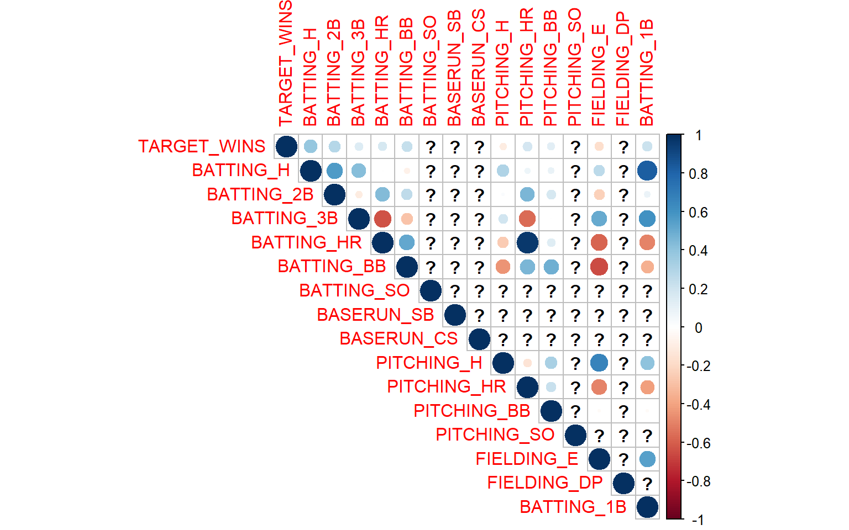

Code

Result shows that BATTING_1B is correlated with BATTING_H, BATTING_2B,BATTING_3B, BATTING_HR. Here +1 and -1 are indicative of sign of coefficient of the respective predictor while stating the value for BATTING_1B.

Corrplot also suggest the same except, it doesn’t show high correlation between BATTING_H``BATTING_HR. In our Model2 , we will just follow the p-value significance test and build the model.

Code

|  |
| --- |
|  |

| **RMSE**  <dbl> | **R2**  <dbl> |
| --- | --- |
| 9.804207 | 0.4255646 |

1 row

**6.0.2 Model 2**

Here alias doesn’t suggest any correlated predictor. Now we can run VIF (variance inflation factor), which measures how much the variance of a regression coefficient is inflated due to multicollinearity in the model. The smallest possible value of VIF is one (absence of multicollinearity). Here we will look for VIF value, if that exceeds 5 or 10 indicates a problematic amount of collinearity. “Read More”[‘<http://www.sthda.com/english/articles/39-regression-model-diagnostics/160-multicollinearity-essentials-and-vif-in-r/>’]

Code

## Model :

## TARGET_WINS ~ BATTING_H + BATTING_3B + BATTING_HR + BATTING_BB +

## BATTING_SO + BASERUN_SB + PITCHING_SO + PITCHING_H + PITCHING_SO +

## FIELDING_E + FIELDING_DP

Code

## BATTING_H BATTING_3B BATTING_HR BATTING_BB BATTING_SO BASERUN_SB

## 23.591594 2.924829 4.274146 1.259010 242.802006 1.539592

## PITCHING_SO PITCHING_H FIELDING_E FIELDING_DP

## 225.307718 48.406757 2.835717 1.353810

VIF output suggest that BATTING_H, PITCHING_H, BATTING_SO,PITCHING_SO are highly impacting model due their colinear relation.

Code

|  |
| --- |
|  |

| **RMSE**  <dbl> | **R2**  <dbl> |
| --- | --- |
| 10.25912 | 0.3883479 |

1 row

6.0.2.1 Model 3

Code

|  |
| --- |
|  |

| **RMSE**  <dbl> | **R2**  <dbl> |
| --- | --- |
| 10.06308 | 0.4060436 |

1 row

6.0.2.2 Model 4

Code

##

## Call:

## lm(formula = TARGET_WINS ~ . - BATTING_H - BATTING_2B - BATTING_3B -

## BATTING_HR, data = moneyball_train)

##

## Residuals:

## Min 1Q Median 3Q Max

## -32.334 -6.834 -0.136 6.517 29.480

##

## Coefficients:

## Estimate Std. Error t value Pr(>|t|)

## (Intercept) 59.857266 8.110353 7.380 3.23e-13 ***

## BATTING_BB 0.006719 0.039339 0.171 0.864410

## BATTING_SO 0.006949 0.022410 0.310 0.756561

## BASERUN_SB 0.035119 0.010675 3.290 0.001036 **

## BASERUN_CS 0.068018 0.022780 2.986 0.002894 **

## PITCHING_H -0.002634 0.006751 -0.390 0.696514

## PITCHING_HR 0.116181 0.012748 9.113 < 2e-16 ***

## PITCHING_BB 0.030035 0.037698 0.797 0.425796

## PITCHING_SO -0.033549 0.021345 -1.572 0.116309

## FIELDING_E -0.127737 0.012193 -10.476 < 2e-16 ***

## FIELDING_DP -0.104855 0.016090 -6.517 1.12e-10 ***

## BATTING_1B 0.038734 0.010312 3.756 0.000182 ***

## ---

## Signif. codes: 0 '***' 0.001 '**' 0.01 '*' 0.05 '.' 0.1 ' ' 1

##

## Residual standard error: 9.86 on 1040 degrees of freedom

## (543 observations deleted due to missingness)

## Multiple R-squared: 0.3933, Adjusted R-squared: 0.3869

## F-statistic: 61.3 on 11 and 1040 DF, p-value: < 2.2e-16

Code

## BATTING_BB BATTING_SO BASERUN_SB BASERUN_CS PITCHING_H PITCHING_HR

## 107.539027 216.776484 2.415563 2.721623 14.163628 4.448142

## PITCHING_BB PITCHING_SO FIELDING_E FIELDING_DP BATTING_1B

## 144.662915 216.288753 2.187153 1.133447 7.973818

Code

|  |
| --- |
|  |

| **RMSE**  <dbl> | **R2**  <dbl> |
| --- | --- |
| 9.922245 | 0.4109811 |

1 row

6.0.2.3 Model 5

Code

##

## Call:

## lm(formula = TARGET_WINS ~ . - PITCHING_SO - PITCHING_BB - BATTING_H -

## BATTING_2B - BATTING_3B - BATTING_HR, data = moneyball_train)

##

## Residuals:

## Min 1Q Median 3Q Max

## -32.408 -6.629 -0.164 6.503 29.704

##

## Coefficients:

## Estimate Std. Error t value Pr(>|t|)

## (Intercept) 60.129049 8.109072 7.415 2.51e-13 ***

## BATTING_BB 0.038506 0.004083 9.430 < 2e-16 ***

## BATTING_SO -0.027830 0.002911 -9.562 < 2e-16 ***

## BASERUN_SB 0.036013 0.010592 3.400 0.0007 ***

## BASERUN_CS 0.066311 0.022725 2.918 0.0036 **

## PITCHING_H -0.010813 0.002702 -4.002 6.71e-05 ***

## PITCHING_HR 0.123928 0.010677 11.607 < 2e-16 ***

## FIELDING_E -0.128182 0.012162 -10.540 < 2e-16 ***

## FIELDING_DP -0.105752 0.016091 -6.572 7.82e-11 ***

## BATTING_1B 0.049404 0.006386 7.737 2.40e-14 ***

## ---

## Signif. codes: 0 '***' 0.001 '**' 0.01 '*' 0.05 '.' 0.1 ' ' 1

##

## Residual standard error: 9.87 on 1042 degrees of freedom

## (543 observations deleted due to missingness)

## Multiple R-squared: 0.3909, Adjusted R-squared: 0.3857

## F-statistic: 74.32 on 9 and 1042 DF, p-value: < 2.2e-16

Code

## BATTING_BB BATTING_SO BASERUN_SB BASERUN_CS PITCHING_H PITCHING_HR

## 1.156266 3.649407 2.373748 2.703075 2.263550 3.113814

## FIELDING_E FIELDING_DP BATTING_1B

## 2.171454 1.131320 3.051488

Code

|  |
| --- |
|  |

| **RMSE**  <dbl> | **R2**  <dbl> |
| --- | --- |
| 9.991091 | 0.4029489 |

1 row

6.0.2.4 Model 6 (Step back)

VIF result suggest that all the predictors in the model step_back have no multicollinearity exist in them.

Code

##

## Call:

## lm(formula = poly_call[2], data = moneyball_train)

##

## Residuals:

## Min 1Q Median 3Q Max

## -29.3740 -6.3034 -0.1952 6.2077 26.1001

##

## Coefficients:

## Estimate Std. Error t value Pr(>|t|)

## (Intercept) 3.188e+02 1.044e+02 3.055 0.00231 **

## BATTING_2B 8.256e-01 5.205e-01 1.586 0.11298

## BATTING_BB -3.382e+00 1.266e+00 -2.672 0.00767 **

## BATTING_SO 4.697e+00 1.527e+00 3.076 0.00215 **

## PITCHING_HR -3.189e-01 1.537e-01 -2.075 0.03820 *

## PITCHING_BB 2.486e+00 9.366e-01 2.654 0.00808 **

## PITCHING_SO -4.661e+00 1.444e+00 -3.227 0.00129 **

## I(BATTING_1B^2) -9.801e-04 3.806e-04 -2.575 0.01016 *

## I(BATTING_2B^2) -4.315e-03 2.036e-03 -2.119 0.03431 *

## I(BATTING_BB^2) 2.121e-03 8.614e-04 2.463 0.01396 *

## I(BATTING_SO^2) -3.678e-03 1.485e-03 -2.477 0.01341 *

## I(BASERUN_SB^2) 1.715e-04 3.723e-05 4.607 4.61e-06 ***

## I(PITCHING_H^2) 9.739e-05 2.992e-05 3.255 0.00117 **

## I(PITCHING_HR^2) 3.322e-03 1.587e-03 2.093 0.03658 *

## I(PITCHING_SO^2) 3.624e-03 1.293e-03 2.802 0.00517 **

## I(FIELDING_E^2) -9.489e-04 1.638e-04 -5.794 9.14e-09 ***

## I(FIELDING_DP^2) -1.756e-03 5.248e-04 -3.346 0.00085 ***

## I(BATTING_2B^3) 6.004e-06 2.623e-06 2.289 0.02227 *

## I(BATTING_3B^3) 6.187e-06 3.269e-06 1.893 0.05867 .

## I(BATTING_BB^3) -5.279e-07 2.966e-07 -1.780 0.07540 .

## I(BATTING_SO^3) 1.640e-06 8.379e-07 1.957 0.05061 .

## I(BASERUN_CS^3) 1.830e-06 7.946e-07 2.303 0.02145 *

## I(PITCHING_H^3) -2.172e-08 7.806e-09 -2.782 0.00550 **

## I(PITCHING_HR^3) -1.344e-05 6.971e-06 -1.928 0.05409 .

## I(PITCHING_BB^3) -1.602e-06 6.497e-07 -2.465 0.01385 *

## I(PITCHING_SO^3) -1.612e-06 6.526e-07 -2.470 0.01369 *

## I(FIELDING_E^3) 1.803e-06 5.822e-07 3.096 0.00201 **

## I(FIELDING_DP^3) 6.100e-06 2.188e-06 2.788 0.00540 **

## I(BATTING_1B^3) 1.125e-06 4.713e-07 2.387 0.01716 *

## I(BATTING_SO^4) -3.008e-10 1.936e-10 -1.553 0.12063

## I(PITCHING_HR^4) 1.703e-08 1.056e-08 1.612 0.10721

## I(PITCHING_BB^4) 8.033e-10 3.398e-10 2.364 0.01826 *

## I(PITCHING_SO^4) 2.908e-10 1.304e-10 2.230 0.02596 *

## I(BATTING_1B^4) -3.810e-10 1.636e-10 -2.329 0.02003 *

## ---

## Signif. codes: 0 '***' 0.001 '**' 0.01 '*' 0.05 '.' 0.1 ' ' 1

##

## Residual standard error: 9.267 on 1018 degrees of freedom

## (543 observations deleted due to missingness)

## Multiple R-squared: 0.4755, Adjusted R-squared: 0.4585

## F-statistic: 27.96 on 33 and 1018 DF, p-value: < 2.2e-16

Code

## BATTING_2B BATTING_BB BATTING_SO PITCHING_HR

## 5.806061e+03 1.260278e+05 1.139708e+06 7.315647e+02

## PITCHING_BB PITCHING_SO I(BATTING_1B^2) I(BATTING_2B^2)

## 1.010821e+05 1.121060e+06 5.540838e+04 2.348083e+04

## I(BATTING_BB^2) I(BATTING_SO^2) I(BASERUN_SB^2) I(PITCHING_H^2)

## 7.326199e+04 2.792078e+06 1.809761e+00 3.504061e+03

## I(PITCHING_HR^2) I(PITCHING_SO^2) I(FIELDING_E^2) I(FIELDING_DP^2)

## 6.304249e+03 2.781515e+06 4.920758e+01 1.318676e+02

## I(BATTING_2B^3) I(BATTING_3B^3) I(BATTING_BB^3) I(BATTING_SO^3)

## 6.147220e+03 6.670212e+00 6.549632e+03 1.487152e+06

## I(BASERUN_CS^3) I(PITCHING_H^3) I(PITCHING_HR^3) I(PITCHING_BB^3)

## 2.175917e+00 1.586654e+03 8.034833e+03 6.941504e+04

## I(PITCHING_SO^3) I(FIELDING_E^3) I(FIELDING_DP^3) I(BATTING_1B^3)

## 1.500893e+06 4.620075e+01 1.312350e+02 2.198039e+05

## I(BATTING_SO^4) I(PITCHING_HR^4) I(PITCHING_BB^4) I(PITCHING_SO^4)

## 1.174857e+05 1.297475e+03 1.615989e+04 1.210049e+05

## I(BATTING_1B^4)

## 5.522947e+04

Code

|  |
| --- |
|  |

| **RMSE**  <dbl> | **R2**  <dbl> |
| --- | --- |
| 9.770826 | 0.4287342 |

1 row

Lets only consider Model with better RMSE and R2 and check it with AIC test:

| **Model Name** | **RMSE** | **R^2** |
| --- | --- | --- |
| model1 | 9.80421 | 0.42556 |
| model2 | 10.2591 | 0.38835 |
| model3 | 10.0631 | 0.40604 |
| model4 | 9.92225 | 0.41098 |
| model5 | 9.99109 | 0.40295 |
| Step Back | 9.77083 | 0.428734 |

Lets run the AIC weight test to evaluate the best model out of few selected models :

Code

## dAICc df weight

## step_back 0.0 35 1

## model4 106.9 13 <0.001

## model5 106.9 11 <0.001

In Both test Model1 is doing well, but since its not a parsimonious model we decided to check among model4 and model5 and step_back. Which is a parsimonious model, with no multicollinearity among the predictors. We also note how multicollinearity in models were impacting its effect on overall performance of the model.

Selected Model = step_back

**6.1 Predict of Eval data**

Run the step_backward model on Eval data.

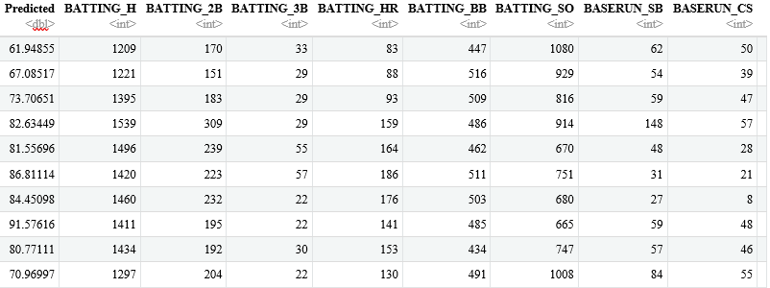

1-10 of 170 rows | 1-9 of 16 columns

From the three models, model3 is a more parsimonious model. There is no significant difference in R2, Adjusted R2 and RMSE even when the treatment for multi-collinearity was done.

**7 CONCLUSION**

This report covers an attempt to build a model to predict number of wins of a baseball team in a season based on several offensive and defensive statistics. Resulting model explained about 36% of variability in the target variable and included most of the provided explanatory variables. Some potentially helpful variables were not included in the data set. For instance, number of At Bats can be used to calculate on-base percentage which may correlate strongly with winning percentage. The model can be revised with additional variables or further analysis.

|  | **kitchen_sink_error** | **simple_error** | **step_back_error** |
| --- | --- | --- | --- |
|  | Min. :-28.3735 | Min. :-27.2876 | Min. :-32.00000 |
|  | 1st Qu.: -6.9033 | 1st Qu.: -7.6292 | 1st Qu.: -7.00000 |
|  | Median : -0.1124 | Median : 0.2432 | Median : 0.00000 |
|  | Mean : -0.0408 | Mean : -0.1372 | Mean : -0.07143 |
|  | 3rd Qu.: 6.4889 | 3rd Qu.: 6.5731 | 3rd Qu.: 7.00000 |
|  | Max. : 27.6495 | Max. : 29.6379 | Max. : 32.00000 |
|  | NA’s :247 | NA’s :143 | NA’s :247 |

# Appendix:

<https://github.com/Rajwantmishra/DATA621_CR4/blob/master/HW1/HomeWork1.Rmd>

# Thank you